Plant Diagram Pre-Test
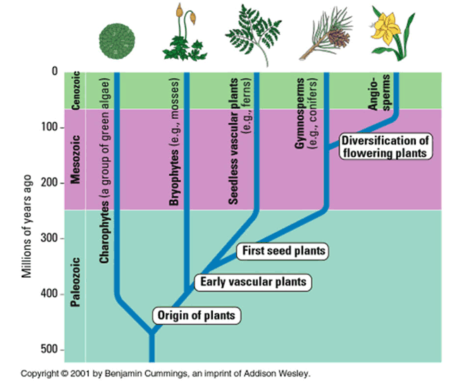
What is this picture explaining?

How does it show this?

What is the key information that you can take away from jus this diagram?

What can you understand about evolution from this diagram?

