Blood Notes
Chapter 12
- Read and take NOTES on the big and the bold words in the chapter
- Use whatever format best suits you.
  - Use some elements of hierarchical organization.

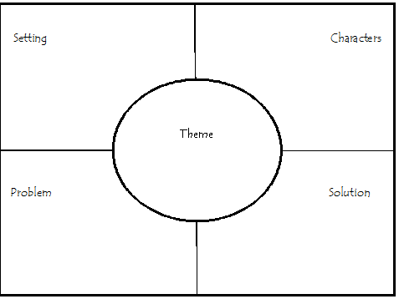
7.1 Introduction
- Bone

- Ske

