Bio Unit5: Genetics Intro TOC# DNA Structure Review Name:_________________

DNA Basics
- What is the function of DNA:

- What is the overall structure of DNA? Draw it.
- The diagram below represents a subunit of DNA. Label the three components.

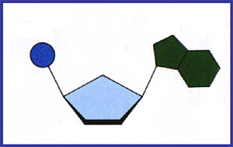

- The diagram below represents a DNA chain. Draw and Label the types of bonds.
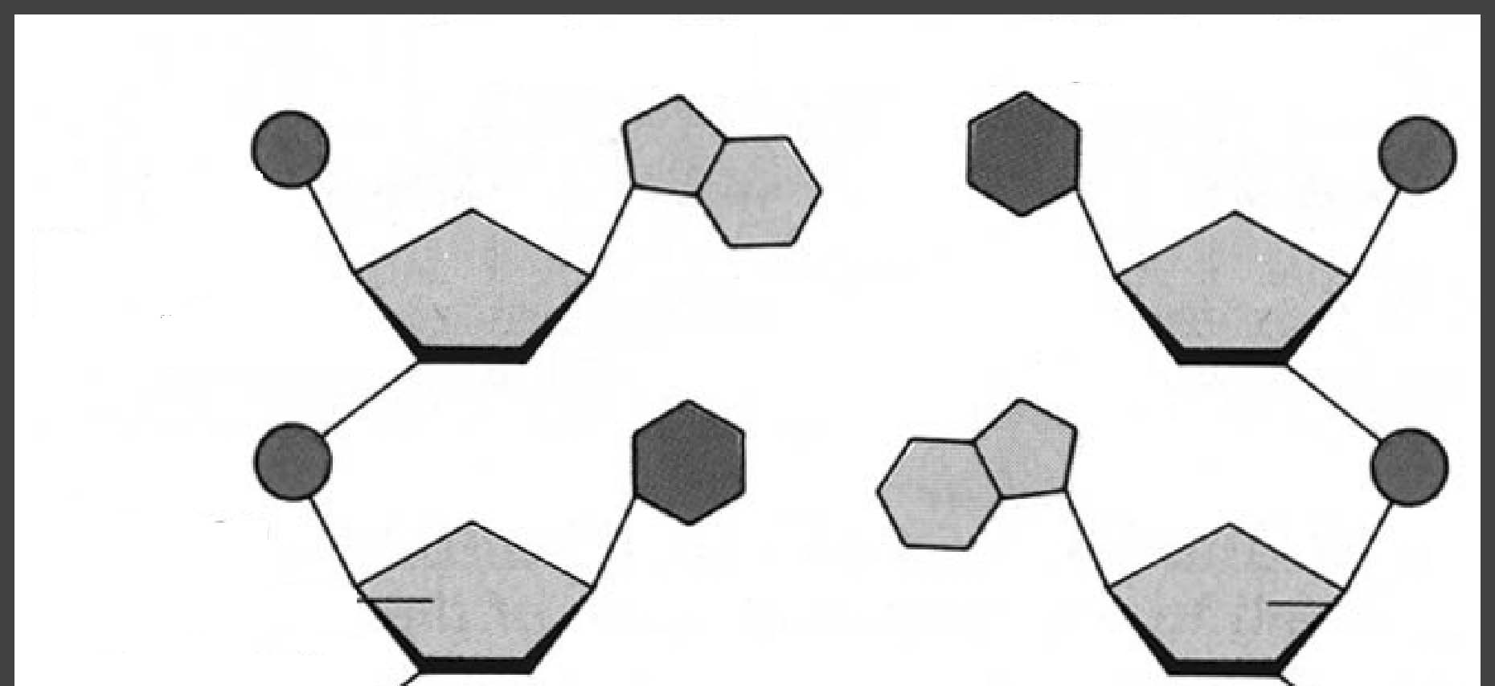

- Organize these structures from small to large: (you can just put the numbers in order)
1)Base, 2) chromosome, 3) nucleotide, 4) double helix

- Chromosomes:
Draw one | What is the purpose | What has to happen to have DNA take that shape?
- During DNA base-pairing, adenine always pairs up with , and cytosine always pairs up with .
Replication:
- What is the purpose of replication?
- What method does DNA Replication use, describe it.

- When DNA splits open, why does it split along the middle (between the bases) and not along the sides?

- What enzyme opens DNA?

- Create the complementary DNA strand:
A T G G C T A C C G A T C G G C A A T

◻ Add the bonds to between the complementary and parent strand above.
- Take this sequence of DNA and make a protein (include all the steps):
A G A T G C T G C G A A A C T T T T G A A A A
⬇

⬇

⬇

⬇

Mutation:
Original strand:
A U G C U G C G A A A C U U U U G A

What type of mutation are each of the following?
- __________ - A U G C U G C G A A A C U U U U G A
- __________ - A U G A C U G C G A A A C U U U U G A
- __________ - A U G C T G CU G A A A C U U U U G A



