Species name: Trachemys Scripta Elegans (Red Eared Slider)

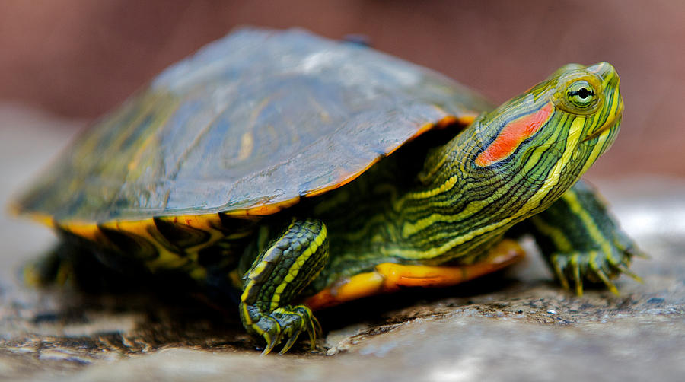

Description: The Red Eared Slider also known, as the Red Eared Terrapin is a semiaquatic turtle belonging to the Emydidde family. It is a subspecies of a pond slider. It is the most popular pet turtle in the United States & is also popular in the rest of the world.
Where it comes from: Originates from the Mississippi river near Gulf of Mexico, they prefer hot climates. They were also found in Virginia and Florida.

How it got here: Humans have released them as pets and have introduced them to places where they can thrive as invasive species.

Why it does so well here: They have a tough shell to defend against predators. It's an omnivore. They are aggressive. They spread diseases to other turtles.

By Simonnicoleman
Who it hurts: The Western Pond Turtle.
Effect on other species: Out competes the native western pond turtle in California.
What can we do to minimize damage: Stop letting people house them as pets so they don’t escape or get released.

