Aquatic Biome Note Guide - Cornell Notes
Practice Exam Question:
What does Fusiform mean? | How is it an adaptation to an aquatic environment and a marine environment?
Using your notes give a 1 sentence description of each marine environment and a possible adaptation to this environment
1. Lentic | 2. Lotic:
Aquatic (freshwater) Biomes:
1. Lentic: ________________________________________________________________________

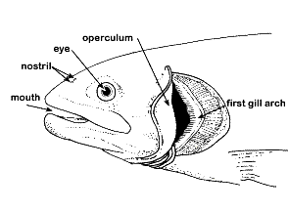
Adapted to: _________________________________

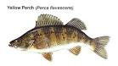 | Fish:
 | Turtle:
Practice Exam Question: How does the cover of a fish gill serve as an adaptation to the lentic biome?

2. Lotic: ______________________________________________________________________

Adapted to: _________________________________

 |  | Fish:
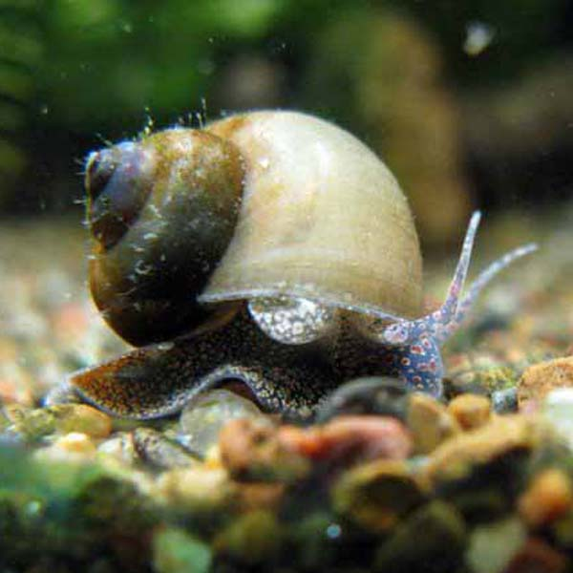 |  | Snail:
Practice Exam Question: What is the difference between Lentic and Lotic Fish gill covers & body shape?

Summary:

