Final Exam Biology Sex Ed Review
- Know for each of the terms:
 | Sex it occurs in | Location | Function
Scrotum | M F  Both
Testes | M F  Both
Seminiferous Tubules | M F  Both
Epididymis | M F  Both
Vas Deferens | M F  Both
Penis | M F  Both
Prostate | M F  Both
Sperm | M F  Both
Ovary | M F  Both
Egg/Ova | M F  Both
Uterus | M F  Both
Cervix | M F  Both
Fallopian Tubes | M F  Both
Hymen | M F  Both
Vagina | M F  Both
Clitoris | M F  Both
Labia (minora & majora) | M F  Both
Mons Pubis | M F  Both
- How does the scrotum help keep cells alive?

- List 2 pros and 2 cons for circumcision:
Pro | Con
- Menstruation:
  - What is menstruation?

  - Why do girls get their period?

- Menopause:
  - What is menopause?

  - Why is it unlikely for a 60-year-old woman to get pregnant? She still has 1000’s of eggs after all.

  - Can anything be done to help a 60-year-old woman get pregnant? What?

- STD/STI’s:
- What are 3 ways to get an STD/STI?

- What are 5 symptoms of STD/STI’s

- What is the difference between viral and bacterial STD/STIs?

    - Which do antibiotics treat?

- Are condoms an effective measure for both birth control and STDs? If so why? How do they work?

- HIV and AIDS attack your T cells, how would this affect a person?

- Making Babies Lab:
  - What is a zytgote?
  - If brown hair is dominant and blone hair is recessive:
    - What color Hair does someone with BB have?
    - Bb:
    - Bb:
    - If both parents have brown hair, could they have a child with blonde hair?

- What are 3 reasons a woman may take birth control?
- Why would testosterone increase when a female is ovulating?

- Hormones:
- Why does a women’s testosterone increase when they ovulate?

- What are the 2 main sex Hormones in women, what do they do?
Hormone | What does it do

- What is the main sex Hormone in men, what are the 3 things it controls?
Hormone

- Hormones & Hormone cycles of men/women – Be able to interpret these graphs:
In Life Time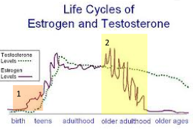 | In a Month:  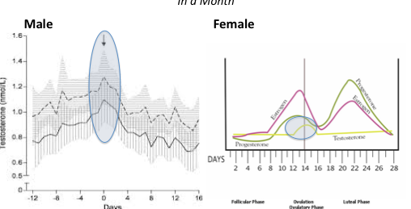

Label:
Male Reproductive System | Terms to Identify
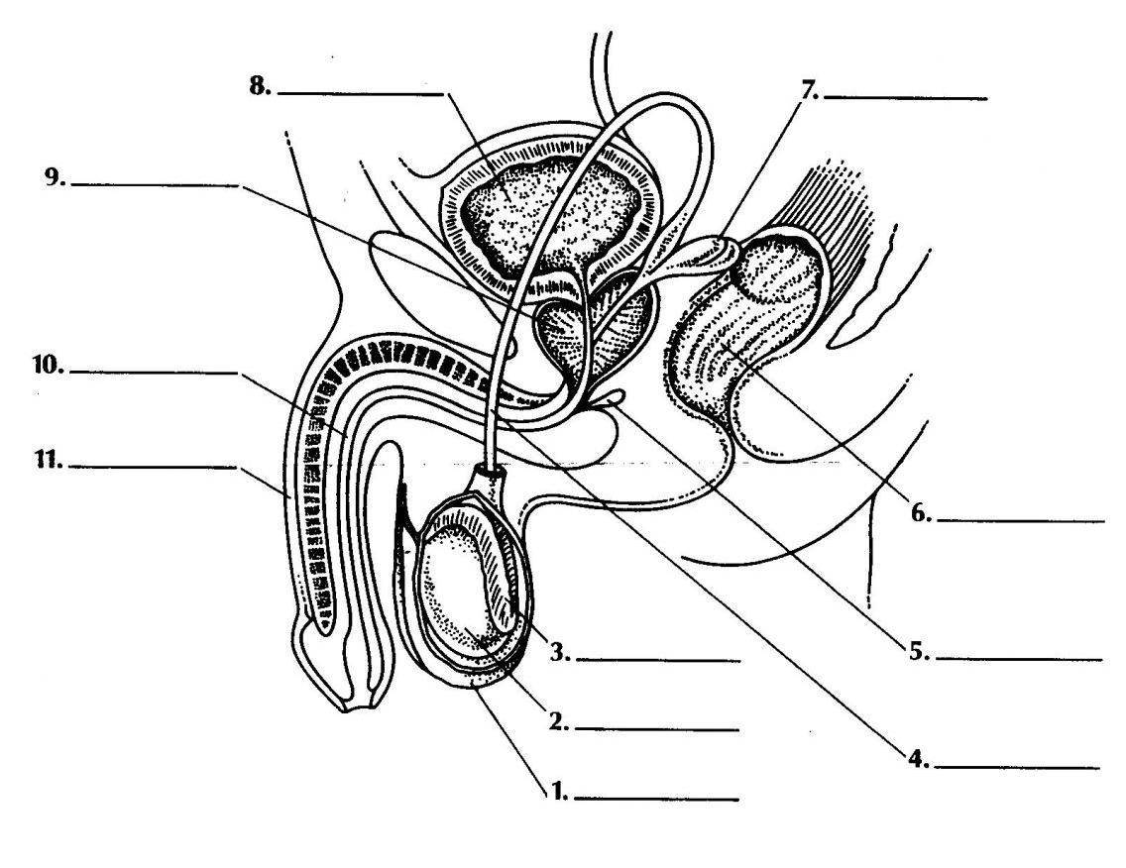 | 1.  2.  3.  4.  5.  6. | 7.  8.  9.  10.  11.
Female Reproductive Anatomy
Internal | External

