Human Skin: A Microscopic Study of an Organ and its Tissues

Background Tissue types, which can mostly be recognized macroscopically, can be organized into sub-groups based on cellular structure and function. Since cells are very small, these differences in cell structure must be observed microscopically.
In this lab activity, we will use microscopes to make these cellular observations and, ultimately, to make the connection between organs and the microscopic tissues/cells of which they are composed. This cellular level of organization is becoming increasingly well understood and is the main focus of most current medical/physiological research. This lab will also provide additional practice in microscopy and microscopic observation/drawing. We will use these skills repeatedly throughout the year.
Some organs in the body are composed largely of one type of cell. For example, the brain is mostly made up of neurons; muscles are mostly made up of muscles cells; glands are made up of epithelial cells. However, many organs are a composite of many different types of tissues. The skin is a good example of this type of organ. Skin, the human body’s largest organ, is composed of three distinct layers: epidermis; dermis and hypodermis (or subcutaneous). Each of these layers contains distinct structures and distinct tissue types. In this lab, you will observe and identify the important layers, structures and tissue types of human skin. You will also have the opportunity to observe the same phenomena of multiple tissue types in the small intestine and blood vessels.
Focus Questions (I will check for these in your binder check)
• What are the major tissue types and sub-types?

• How can those tissue types be identified microscopically?

• What tissue/cell types compose skin, blood vessels and small intestine? What are the roles of those tissues in the function of those organs?

Split into 2 groups: Pre Labers and Microscopers
Part I: Human Skin
A. Pre-lab Preparation
- Draw and label one set of the flowing diagrams:
      - Fig. 6.1
(a) | (b)
Page #: . |  | Figure #:

Part II. Human Tissue Types
A. Pre-lab Preparation
  - Basic Connective tissue groups:
 |  | Pre Lab |  | Lab
Name |  | Structure | Function | Microscopic Scientific Drawing:
Connective  Blood |  |  |  | Magnification: _____________X
Connective  Bone |  |  |  | Magnification: _____________X
Connective  Cartilage |  |  |  | Magnification: _____________X
Connective  Adipose |  |  |  | Magnification: _____________X

  - Basic Tissue groups:
 | Pre Lab |  | Lab
Name | Structure | Function | Microscopic Scientific Drawing:

Connective  Fibrous (Ligament) |  |  | Magnification: _____________X
Epithelial  Human Skin |  |  | Magnification: _____________X
Muscle  Striated (Skeletal) |  |  | Magnification: _____________X
Nervous  Motor nerve cells |  |  | Magnification: _____________X

B. Microscopic Study of an Organ– Layers/Structures of Human Skin
- Create a wet mount of your hair
  - Conduct a microscopic observation at 40X.
Name of Slide:  Your Hair |  | Magnification: _____________X
- Examine a tape section of your own skin
  - Conduct a microscopic observation at 40X.
Name of Slide:  Your Epithelium on tape  Q:What cell type is this? |  | Magnification: _____________X
- Make the following detailed microscopic drawings at the most useful magnification:
- You should also identify and label as many of the following structures as possible:  - Use figure 6.1 to help label this:  - Epidermis  - Dermis  - Hypodermis  - Sweat gland  - Blood vessels  - Sebaceous (oil) gland  - Fat  - Muscle  - Sensory nerves  - Draw and label  - Accessory structure  - 3 cell types | Magnification: _____________X

TEACHER SECTION

Connective:  Blood | Connective:  Bone | Connective:  Cartilage
Epithelial:  Skin | Muscle:  Striated | Nervous:  Motor Nerve Cells
Wet Mount:  Your Hair | Tape Mount:  Your skin | HUMAN SKIN

Fibrous Connective Tissue:
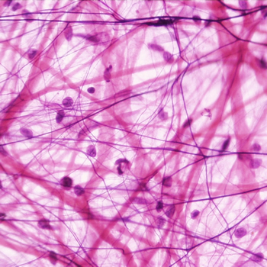 | Thick pink bands are the protein collogen, while the thin dark threads are the protein elastin.  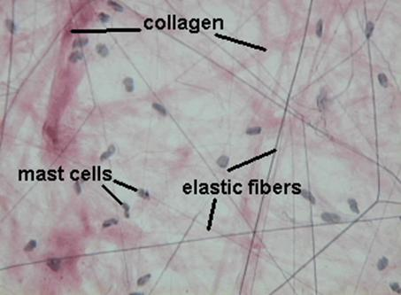
Magnification: >2000X
//kentsimmons.uwinnipeg.ca/cm1504/15lab42006/lb4pg6_files/image004.jpg

Adipose Connective Tissue:
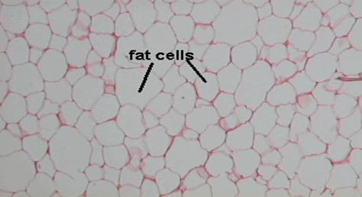 | Why is the nucleus on the side of an adipose cell?  When you gain fat, do you gain more fat cells?  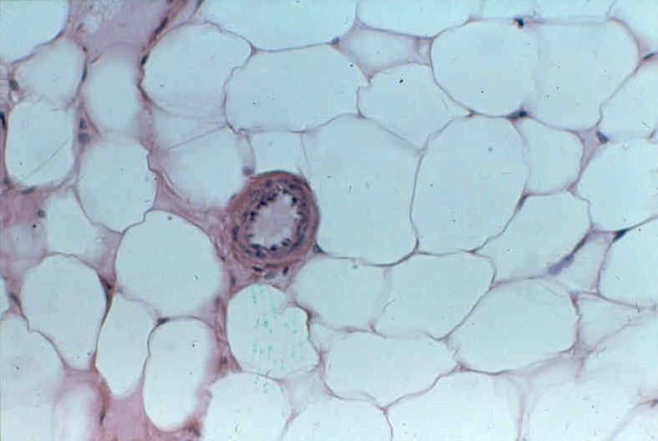
Magnification: >2000X
http://kentsimmons.uwinnipeg.ca/cm1504/15lab42006/lb4pg6_files/image009.jpg

