Physiology Unit 3 Review
OLD Stuff: (Review old Quiz and Review materials)
Drugs:
- What hormone is affected in most of these cases?

- What is meant by a serotonin re-uptake inhibitor?

Reflexes
- Reflex Arc: (Draw and Label)

Nerve Distance
- Why cant you perceive 2 separate points of contact on the inside of your 4arm?

NEW Stuff:
EYE
- Label this Eye:
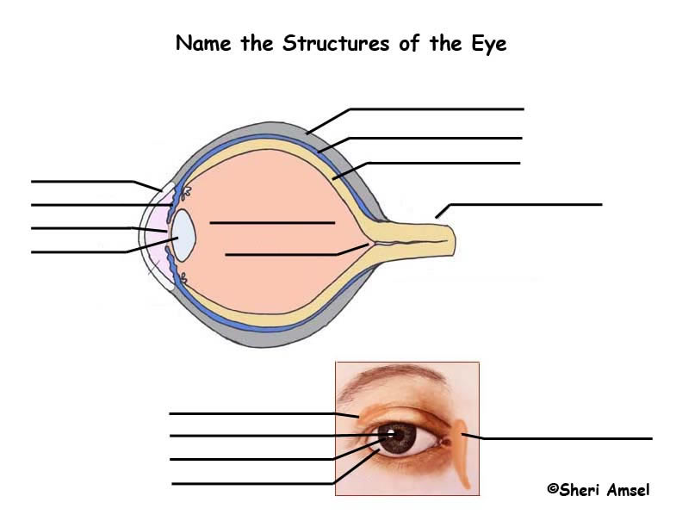
- Know the main function of each part of the eye:
- What are rods and cones, how are they different?

- How can lenses correct astigmatism?

Taste/Smell:
- What part of your brain perceives this info?

- Why are smell and taste so linked together?

ENDOCRINE NOTES:
- Main Goal: UNDERSTAND WHAT CAUSES THE VARIOUS DISEASES AND WHICH HORMONES AND GLANDS THEY STEM FROM
- Go over scenarios from TOC17
- Go over practice Diabetes Quiz
- Label
