Body System: __________________________________________
System #

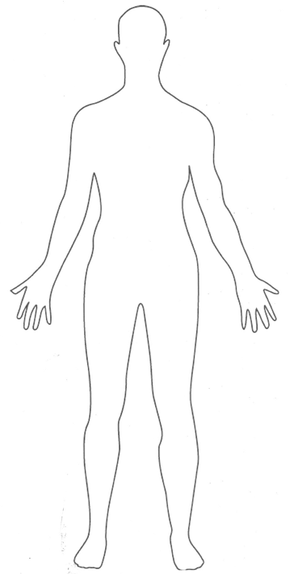
Fun Fact
Body System: __________________________________________
System #
- The main function of this Body System

- The name & function of all of the organs
________________________________________________________________________________________________________________________________________________________________________________________________________________________________________________________________________________________________________________________________________________________________________________________________________________________________________________________________________________________________________________________________________________________________________________________________________________________________________________________________________________________________________________________________________________________________________________________________________________________________________________________________________________________________________________________________________________________________________________________________________________________________________________________________________________________________________________________________________________________________________________________________________________________________________________________________________________________________________________________________________________________________________________________________________________________________________________________________________________________________________________________________________________

- Identify at least one relationship to another body system.

How do they work together?

- Identify any specific diseases that affect each body systems
Name of disease:

How it affects the organ system/human body:

