Practice for Evolution Test - Key

- Evidence for Evolution Theory
Direct observation – we see it happening today | Biogeography | Comparative embryology
The fossil record | Comparative anatomy | Molecular Biology

- Homology = The similarity in structures due to common ancestry ___________________________
- An example of it is: 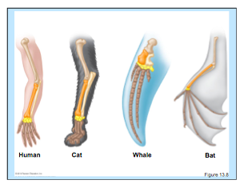
- How is homology an example of evolution? Comparative anatomy – Shows common ancestry by virtue of the most likely scenario that they all changed slightly from the common ancestor, compared to each evolving it separately.

- Evolution = genetic change in a population over time

- What makes a trait an adaptation? Changes as environment changes – example sickle cell

- How is sickle cell disease an adaptation? (talk about heterozygous benefit for malaria)
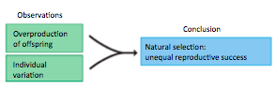
- What are the two things needed for natural selection to occur?
- Sexual Selection is: When a genetic trait becomes more abundant in a population because it helps you to get more mates, not because it helps you live longer (Think peacock)

- Bottleneck effect is an example of:_____________________(Genetic Drift)
- How are elephant seals and example?

- What is the biological description of a species? The most commonly used definition of species is a population that is capable of interbreeding to produce healthy, fertile offspring.

- How do reproductive barriers maintain species? reproductive barriers prevent members of different species from breeding.
  - Give 5 examples of barriers
Behavioral isola6on: Members of a species (identify each other through specific rituals.) | Mating time differences: Many species are able to reproduce only at specific times. | Habitat isolation: If species live in slightly different habitats, they may never meet
Mechanical incompa6bility: Members of different species (cannot mate because their anatomies are incompa1ble. | • Gametic incompability: The gametes (sperm and egg of different species usually cannot fer1lize each other. | • Hybrid weakness: Offspring of two species may be unfit, or they may be sterile.

