Rate of Photosynthesis ~Conclusion Guide~
Title: Summarizes experiment

Paragraph #1: What background information supports the experiment?
- Photosynthesis
•Purpose

•Location: What organelle and where in that organelle

Equation:
Reactants (what goes in) | Products (what comes out)

Paragraph #2: Light Vs Dark Reaction:
Light Reaction  Why called Light Reaction? | 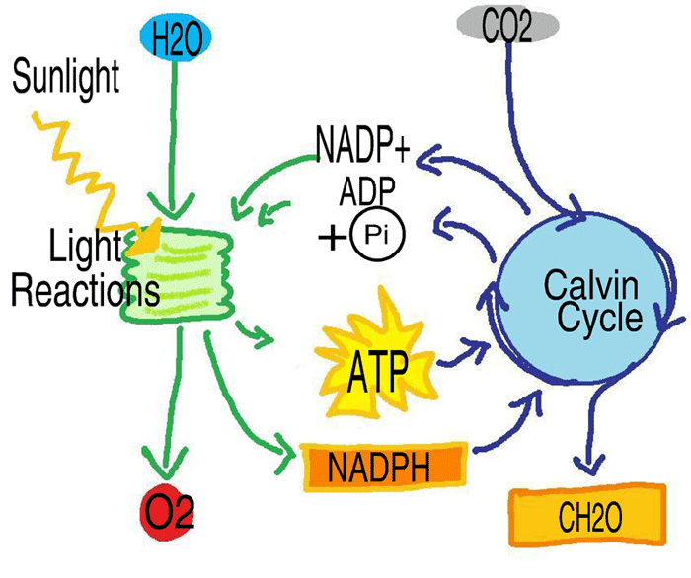 |  | Dark Reaction  Why called Dark Reaction?  Why is that not entirely correct?
Where does it occur?  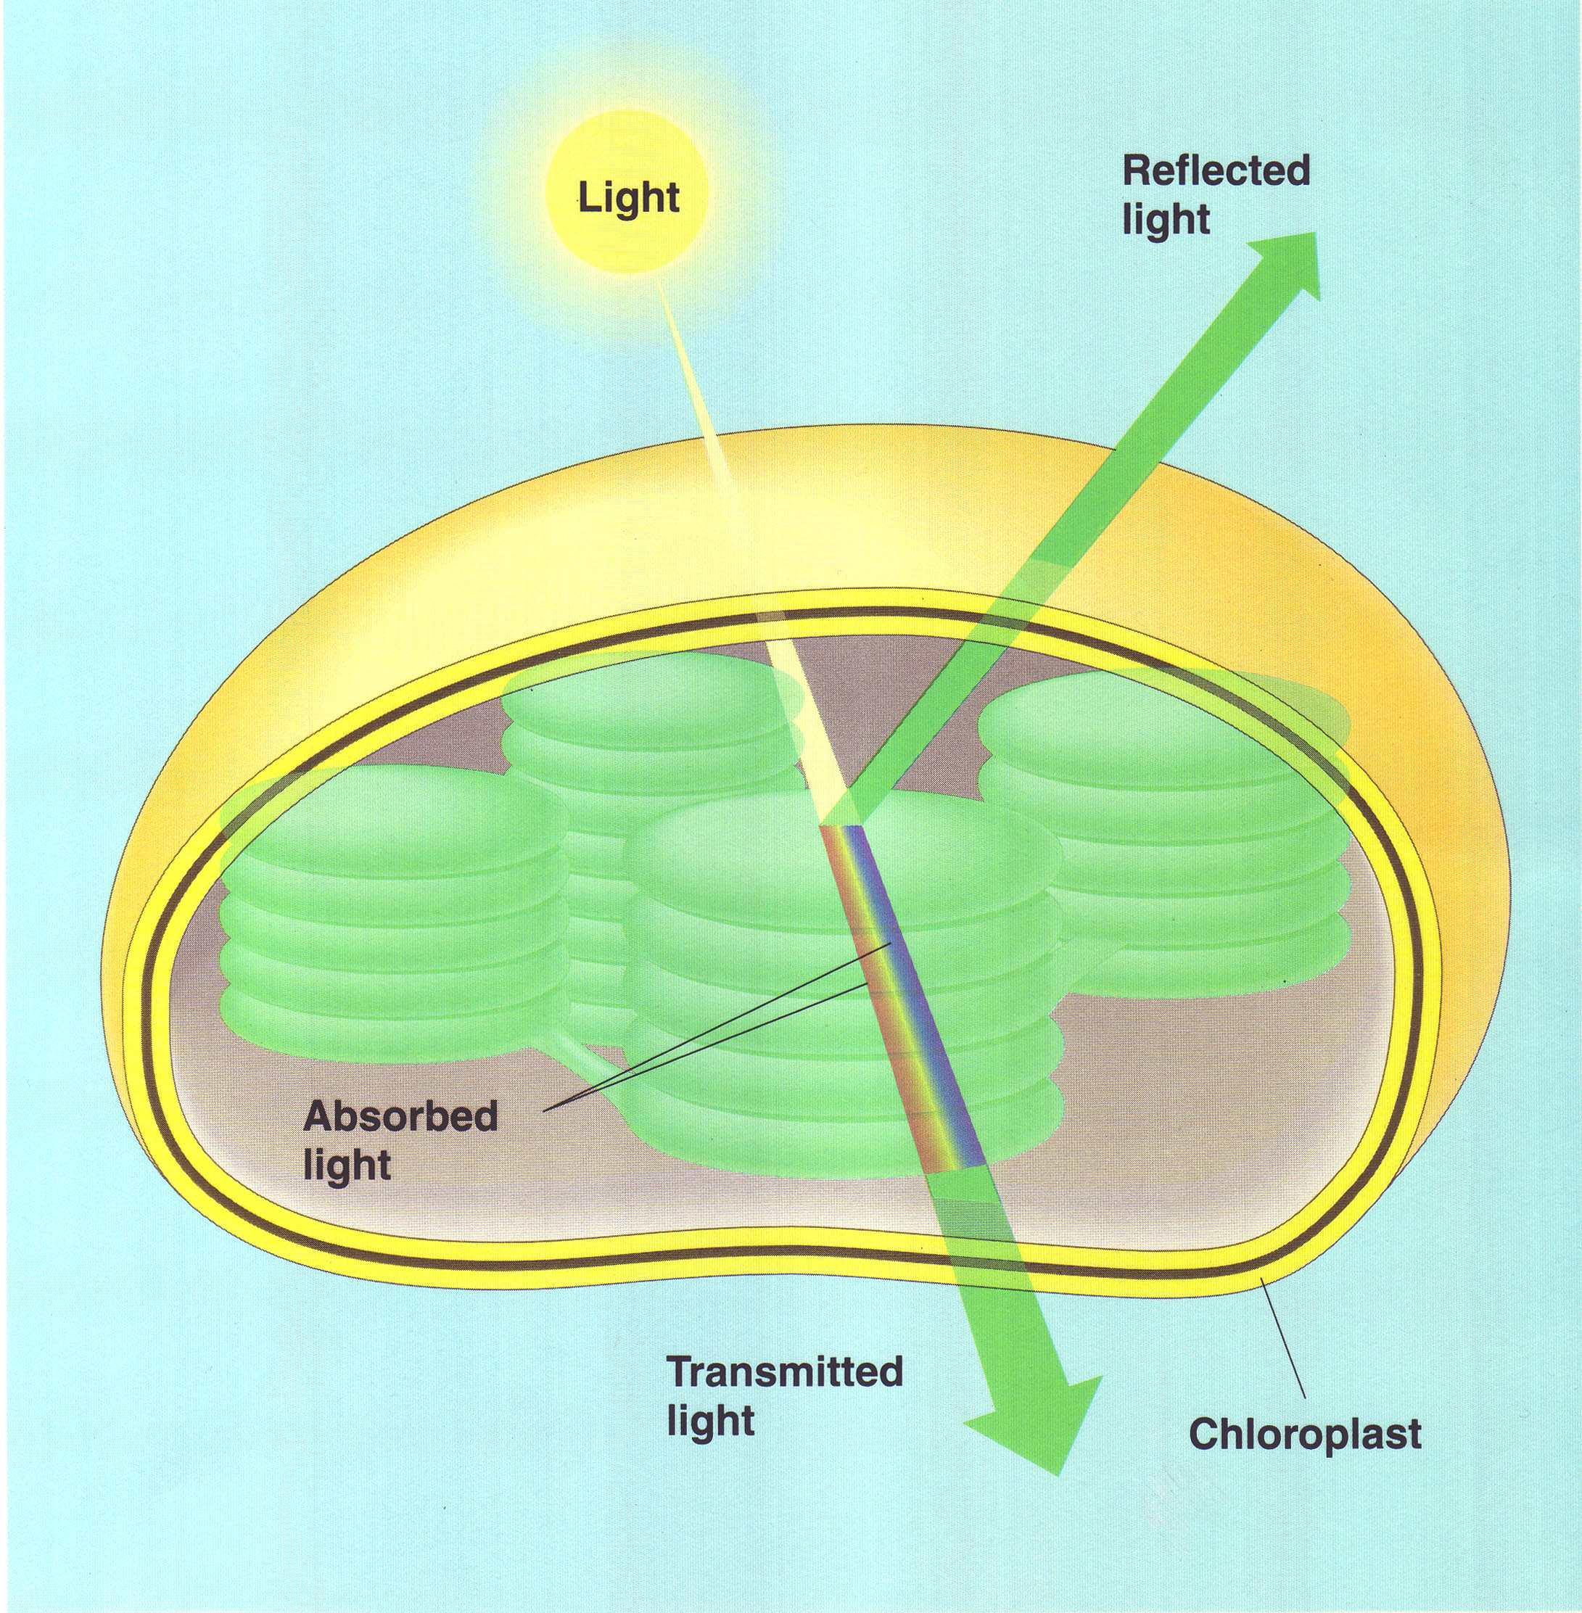 |  | Where does it occur?
Energy formed: as _____________  __________ energy and the splitting of __________ store ________________ energy |  | Energy formed: The energy stored in the light reaction is used to convert __________________ into _________________ AKA SUGAR!
Take in:  •H₂0 & Light  _______________________________ |  | Take in:  •CO₂  _________________________________
Release:  •ATP  •Waste: _________________ |  | Release:  •Sugar (Glucose – C₆H₁₂O₆)  •Waste: _______________________________

Paragraph #3: Why is the experiment being done?
- Why do we care how much photosynthesis is occur in?

  - What is the connection between photosynthesis and the human population?
Energy | Food | Oxygen
Food Web: | STARVATION | 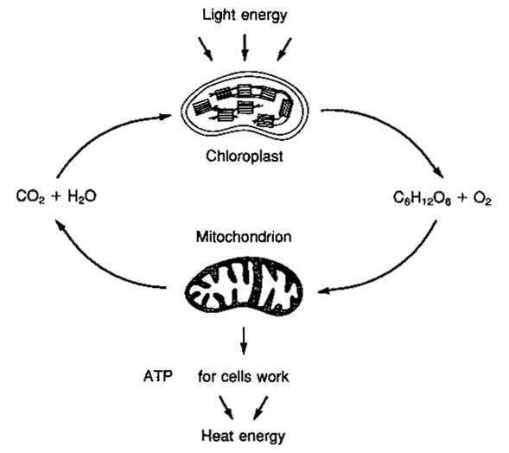  How are these two pictures the same?
- Make a recommendation for protecting or destroying the sun:

HOMEWORK!!! Paragraph #4: What are the predicted outcomes of the experiment? Explain
- State predictions:

- Explain why you expect each test to result as predicted
Low light intensity | Med light intensity | High light intensity
- What other factors might affect the rate of photosynthesis? (Hint: consider the reactants in the photosynthesis reaction)

