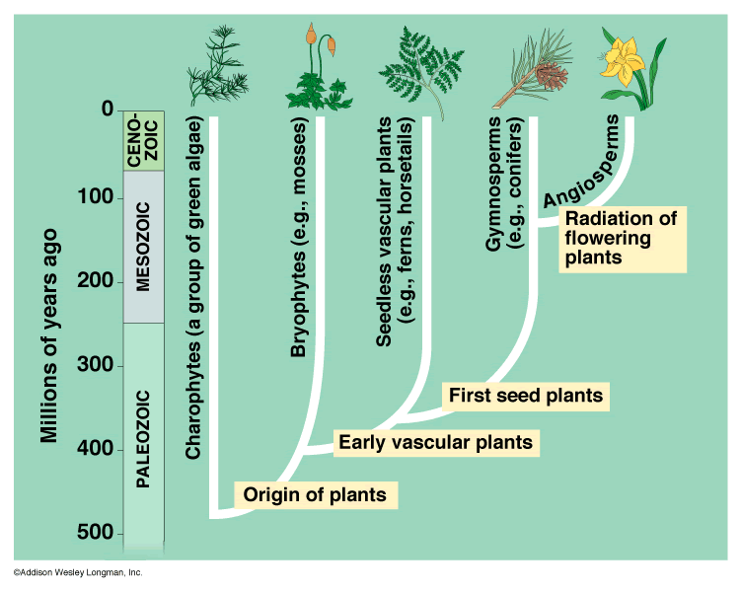

**Each plants Big Addition to Life on Land**

**Charophytes**:

**Bryophytes**:

**Pterophytes**:

**Gymnosperms**:

**Angiosperms**:

**Summary**:

**What does this tell us about the evolution of plants?**

Label and color:

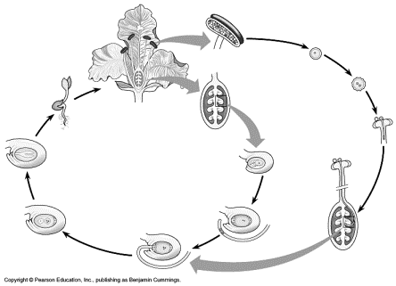

Explain alternation of generation:

|  |  |
| --- | --- |
| MacHD:Users:Zannie:Desktop:Screen Shot 2015-04-28 at 4.02.27 PM.png | MacHD:Users:Zannie:Desktop:Screen Shot 2015-04-28 at 4.03.42 PM.png |
| MacHD:Users:Zannie:Desktop:Screen Shot 2015-04-28 at 4.04.33 PM.png | MacHD:Users:Zannie:Desktop:Screen Shot 2015-04-28 at 4.05.46 PM.png |