Notes: Introduction To Ecology
Comments: | Notes:
AKA:  BIOTIC = Living  AKA:  ABIOTIC = NOT Living  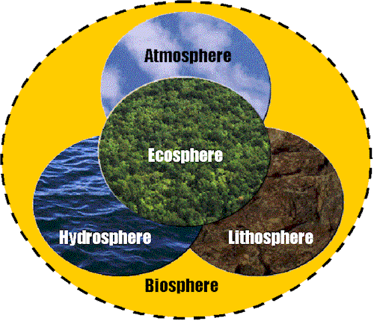 | - Origin of the word…”ecology”  Greek origin  - OIKOS = household  - LOGOS = study of…  Together: Study of the “house/environment” in which we live.  - Ecology is study of interactions between  - Non-living components in the environment…  Light/ water/ wind/ nutrients in soil/ heat/ solar radiation/ atmosphere, etc.  - Living organisms…  Plants/ Animals/ microorganisms in soil, etc.  - To study Ecology involves…  - For non-living (abiotic)  Climatology/ Hydrology/ Oceanography/ Physics/ Chemistry/ Geology/ soil analysis, etc.  - Levels of Organization - a hierarchy of organization in the environment  - Levels of organization - Terms  - Biosphere: Surface of the earth, Composed of many ecosystems  Biosphere: Surface of the earth, Composed of many ecosystems  ⇓  Ecosystem: Large or small as we decide (Backyard, Samuel P Taylor Park, etc.)  ⇓  Population: one species live in one place at one time  ⇓  Community All populations (diff. species) that live in a particular area.  ⇓  Habitat – physical location of community  ⇓  Organism – simplest level of organization  Preview: ________________________ Relationships:  Symbiosis: living together with another organism in close association  Mutualism (+/+) Commensalism (+/0) Parasitism (+/-)
Summary:

