Cardiovascular System
- Function of system:

- What is the function of each circuit:
Pulmonary Circuit | Systemic Circuit
DIFFERENCES | DIFFERENCES
Which is bigger?

- Valves
- Draw one:

- Function

- Label the Pieces:
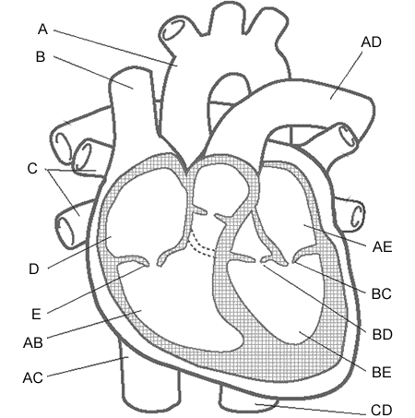 | A:  D:  AB:

- SA Node: What is the Purpose?

- How and why are arteries and veins different?

