Bioaccumulation Lab
Procedure
- Cut out your food web.
- Assemble your food web.
- Connect the food web.
- Add mercury to the habitat
- Follow the mercury up the food chain
Analysis Questions
- Why is a food web more accurate than a food chain?

- Did the top of the food web or the bottom of the food web die first?

Why?

- In your own words, define “bioaccumulate.”

- What percentage of the entire food chain died as a result of bioaccumulaion?

- Why did some animals survive the bioaccumulation?

- Zooplankton and Oysters are animals that filter feed on particles like plankton from the water. How could dining on filter feeders affect a person’s health?

- Is it better to eat oysters or tuna fish that eat zooplankton?

- Other than mercury, what also bioaccumulates?

Post Lab Research:
Research and take notes on one other bioaccumulating particle and how it affects the species in the food web.
Include:
- The food web it affects (include pic/diagram)
- Where the molecule comes from
- How it affects the top predators (Include a picture)
Food Web Icons – To Cut out and clip clothespin to as a weight
 | 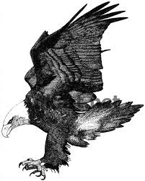
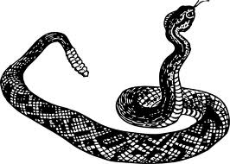 | 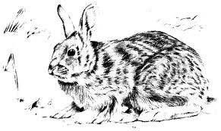
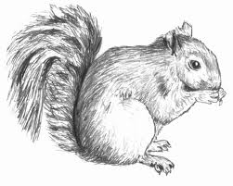 | 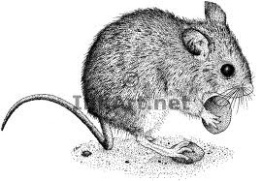
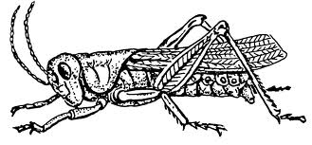 | 