Keystone Species Notes
What is a Keystone?
- The term “keystone” derives from architecture.
- The keystone in an arch is the stone at the top of the arch, which holds the rest of the stones in place and allows the arch to bear weight.

Q: What would happen if you removed the keystone?

Keystone Species Definition:
1) A keystone species is a species whose impact on its community or ecosystem are larger and greater than would be expected from its relative abundance or total biomass in the environment.
2) Keystone species play the same role in many ecological communities by maintaining the structure and integrity of the community.
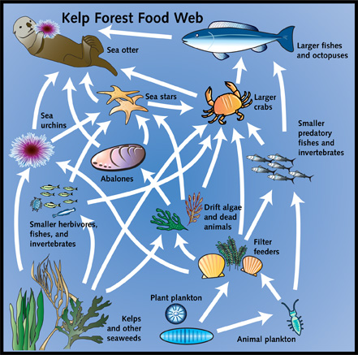 |  | Keystone Species: Sea Otter  Food Web Overview:  1.Sea Otters eat urchins  2.Urchins eat Kelp  Q: What happens when Sea Otters Decline?  Keystone Engineers
Types of Keystone Species
- Predator: Control populations of Prey
  - EX:

- Prey: Provide important food source
  - EX:

- Modifier/Engineer: Change the environment around them.
  - EX:

- Mutualist: Mutually beneficial interactions – AKA link species
  - EX:

- Host: Provide home and protection for a disproportionate number of species.
  - EX:

The prairie dog serves as a keystone engineer.
- By digging burrows, the prairie dog creates homes for other animals, including burrowing owls, rabbits, snakes, and insects.

- In addition, by churning the soil:
  - Mix nutrients
  - Allow water to penetrate deeper
  - Help the prairie sustain more plant life
  - Increasing the overall primary productivity of the community.

Q: What 2 roles do prairie dogs perform as keystone engineers?

Q: How are prairie dogs like upwelling?

Indicator Species
- A species whose presence, absence, or relative well-being in a given environment is indicative of the health of its ecosystem as a whole.

- Basically: A Species that tells people what is going on in an ecosystem

Overview of Keystone Species

