Plant Evolution Essay Rubric
Edited
TOC#4
 |  | Title
¶1 | Introduction | ☐ Introduce paper  ☐ Phylogenetic tree  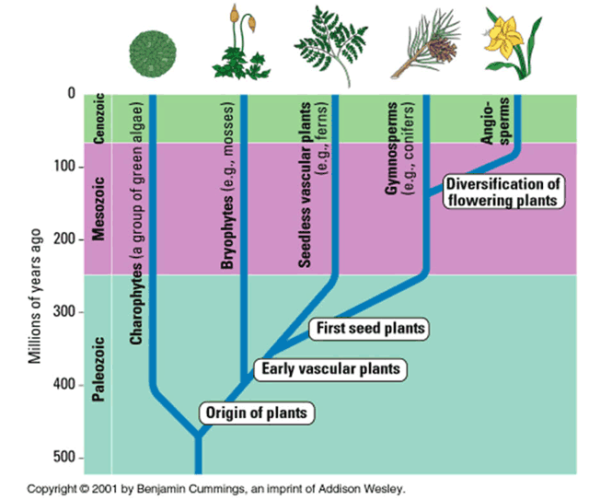 |  | ☐ Characteristics of plants  1.Chloroplasts  2.Cell wall  3.Photosynthesis  ☐ Connection to the rest of the food web
¶2 | Charophytes | ☐ Identify as green algae  ☐ Not True plants  ☐Ancestral Plants  ☐ Live in water  Unless as lichen |  | ☐Non Vascular  ☐Effect on shape: Long and Skinny to promote osmosis  ☐ Spirogyra
¶3 | Bryophytes | ☐ Identify as moss  ☐ Live on land  ☐ Non Vascular  ☐Effect on shape  ☐ Phylid not Leaf, Rhizoid Not Root - Why?  ☐ How do they hold onto water? |  | ☐ NO Seed (spore instead)  ☐ Do they rely on water for reproduction? (Yes, why?)
¶4 | Adapt 2 Land | Adaptation to Land:  Major problem they need to deal with on land  Hold Water  - Stomata + Cuticle |  | Move Water  - Vascular Tissue (Xylem/Phloem) + Transpiration
¶5 | Pterophytes | ☐ Identify as Ferns  ☐ Live on land  ☐ Vascular  ☐Effect on shape: |  | ☐ NO Seed (spore instead)  ☐ Sori  ☐ Do they rely on water for reproduction?
¶6 | Gymnosperms | ☐ Identify as Conifers/Pine trees  ☐ Live on land  ☐ Vascular  ☐Effect on shape: Can grow REALLY tall  ☐Why? They have AMAZING VASCULARITY  ☐ How do they move water  ☐ Xylem for water  ☐ Phloem for food |  | ☐ Seed  ☐ Do they rely on water for reproduction? (No: Can live farther from water)  ☐ In cone  ☐ Connect Cone to Flower
¶7 | Angiosperms | ☐ Identify as Flowering Plants  ☐ Live on land  ☐ Vascular  ☐Effect on shape: Can grow tall  ☐ How do they move water  ☐ Xylem for water  ☐ Phloem for food |  | ☐ Seed  ☐ Do they rely on water for reproduction? (No: Can live farther from water)  ☐ Flower  ☐ Why are flowers pretty?
¶8 | Conclusion | ☐ Explain what evolution is, why and how organisms do it.  ☐ Conclude about the evolution of plants  ☐ A slow process = Takes many/small steps  ☐ Define and include: Derived, Ancestral, Evolution, Adaptation, Natural Selection
End | Bib | ☐ Used 2 references  ☐ Cited in text  ☐ Organized into bibliography at the end of paper
Score |  |  | _____/______

