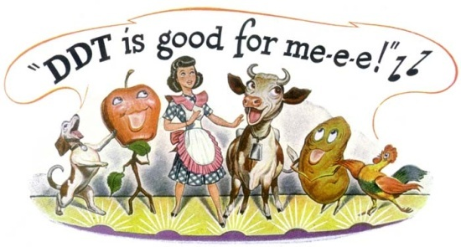
Ecological Impact of DDT

•What is a Pesticide | •Chemical used and created by humans to kill and control undesirable organisms (such as insects or certain plants)  +  -
•What is DDT? | 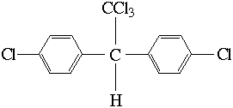  •One of the most commonly used and well known pesticides in the world.  •It was created in a laboratory in 1873 and it’s scientific name is  dichlorodiphenyltrichloethane.  •In it’s pure natural form, DDT is a white crystalline powder with minimal odor.
•History of DDT | Created in a Laboratory in 1873  •1939, Dr. Paul Muller discovered DDT also effective in killing insects  •During WWII, DDT used to kill mosquitoes that spread malaria and other insect-borne human diseases among civilians and the military  •After the war, DDT was commercialized and accessible to the public  •The U.S. used and produced millions of pounds of DDT during the mid 1900’s  •In 1972, the EPA banned the sale of DDT for use on crops  •The U.S. no longer uses DDT, but many other countries in the world continue to use it to control malaria (as in the tropics) or other insect-borne human diseases
Dangers of DDT | •DDT does not break down in the environment or in living organisms  •It has a long life span, which is due to its high solubility in fat and low solubility in water  •High solubility in fat means that the DDT will secrete in the fat of an animal or person and stay there  •Since it is stored in the fat of an organism, it can be easily passed down through the food chain
How DDT Enters the Body and How it Works  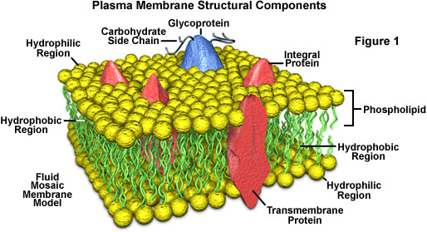 | DDT cannot enter the body through the skin, but instead through mucus membranes and through the mouth  •Once inside the body, DDT is secreted into the gastrointestinal tract  •DDT works by entering a cell through its plasma membrane  Effect on Humans:  •DDT is also an estrogen mimic  •An estrogen mimic is a molecule that attaches itself to an estrogen receptor in a cell and mimics the action of the body's natural estrogen  • Men's ⇓ sperm counts since the mid 1940's and a rise in the number of cases of endometriosis in woman are being studied to determine whether there is a link to DDT  How it Works  •DDT dissolves the membrane of cells  The problem with the way DDT gets into the cell is that it leaves the membrane open, which causes the cell to leak.  ⇓  Once in the plasma membrane, DDT does not allow nerve impulses to fire when they are supposed to  ⇓  When an organism is poisoned with DDT it dies by either convulsions or paralysis
•DDT’s Effect on the Environment | •DDT's breakdown product is DDTr  •Since DDT is fat soluble, water does not wash it away and it remains in the soil where crops were once treated with DDT  •DDT can still be detected in water years after it was introduced into a stream or lake
“Silent Spring” | 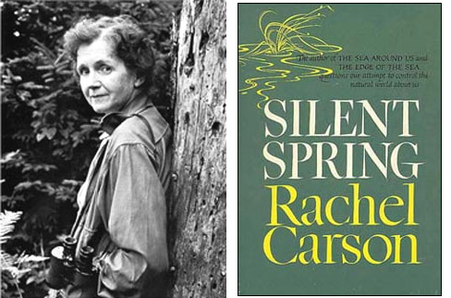  •Book written by Rachel Carson in 1962  •Addressed the dangers of DDT to the public
•Effects of DDT on Animals and Small Organisms | •DDT can affect the growth of an organism as small as a microorganism  •Causes many problems in fish by disrupting important biological processes  •Causes problems in birds by damaging reproductive enzymes that determine crucial biological processes  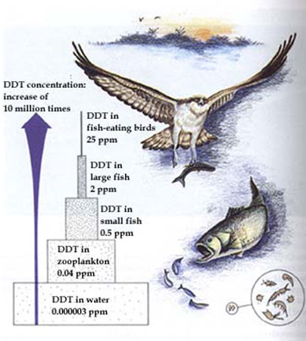  Making the egg shells of top predatory birds more fragile  - EX: bald eagles and brown pelicans  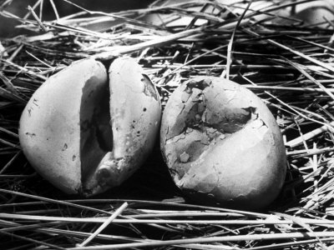
Explain the Process:

What is this process called?

What World Leaders are Doing About This Problem | •The international community has agreed on eventually eliminating the use of DDT in the fight against malaria  •World leaders have also called upon financial institutions to work towards efforts to develop other strategies for combating malaria and other insect borne diseases without the use of harmful chemical products
How to Eliminate DDT? | •Because of its sustainability, DDT may never be completely eliminated from the environment  –Although DDT may never be completely eliminated, a new CO2 cleaning process is successfully reducing the amounts of DDT in the environment  –Under extreme temperature and pressure, CO2 is capable of working as a solvent for DDT in soil  –The unfortunate reality of this new technology is the cost, which may prevent it from being used to its fullest potential
Work Cited
•Adapted from: blumberg-lab.bio.uci.edu/past%20teaching/bio2B.../DDT-tonatiuh.ppt- Tonatiuh Hernandez
•http://www.oneworld.net/article/view/110927/1/ddt.cfm
•http://www.chem.duke.edu/~jds/cruise_chem/pest/pest1.html
•http://www.epa.gov/history/topics/ddt/01.htm
•www.cdpr.ca.gov
•ehp.niehs.nih.gov/qa/105-8forum/forum.html

