Unit 3: Nervous System Brain Concept Map TOC#4

Concept Map Terminology  Use the terms below to complete the concept map. You need to add the functions to the empty boxes in the concept map. Include connecting terminology between boxes next to the arrows! Use your text book to guide you and any other resources that may be useful.  - Cerebrum  - Frontal lobe  - Parietal lobe  - Occipital lobe  - Temporal lobe  - Diencephalon  - Thalamus  - Hypothalamus  - Optic tracts, optic chiasma, infundibulum, posterior pituitary gland, mammillary bodies, pineal gland  - Limbic system  - Cerebellum  - Brainstem  - Pons  - Midbrain  - Medulla oblongata | 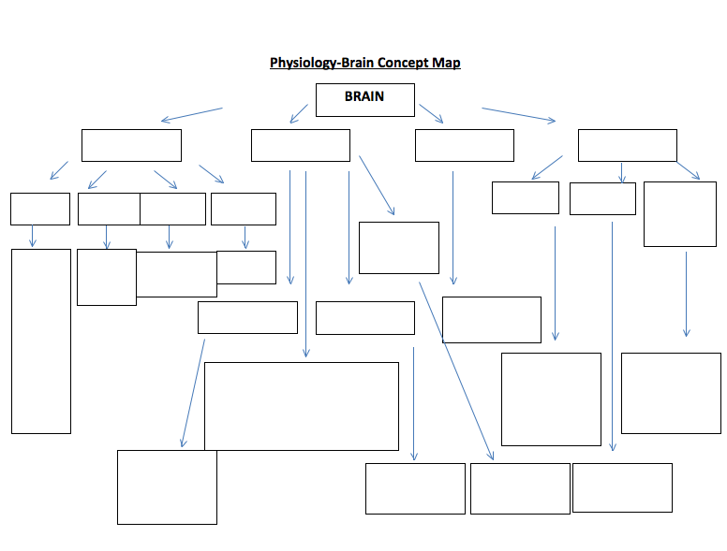  Limbic System

