LAB: HOW DO MALE & FEMALE SKELETONS COMPARE?

Goals
Identify the physical variations and the evolutionary reasons for anatomical skeletal differences between the sexes.
Introduction
If a skeleton is found, experts such as forensic anthropologists can make determinations of the gender of the individual based on several factors, including pelvis structure. When actual pelvises are not available for study, pelvis models given on paper can assist in visualization of anatomy differences between males and females. In this exercise, you will examine and measure diagrams of pelvises of a male and female, and determine if a third pelvis is that of a male or female.

Procedure
- Complete Pre Lab – Last Page.
- Form a hypothesis:
If:

Then:

Because:

- Examine the diagrams of the pelvises shown on the back of the page.

- Measure the width of each pelvis in millimeters. Use the dotted line labeled a on each diagram as a guide.

Diagram | Pelvis Width | Sacrum |  | Opening Size | Bottom Shape | Thigh Position | Pelvis Form
Diagram | Pelvis Width | Length | Width
A |  |  |  |  |  |  | Male
B |  |  |  |  |  |  | Female
C |  |  |  |  |  |  | UK:_______________

- Measure the length and width of the sacrum, which consists of fused vertebrae and which is shaded for your identification. Use the dotted lines b (length) and c (width) as guides. Record results in data table.
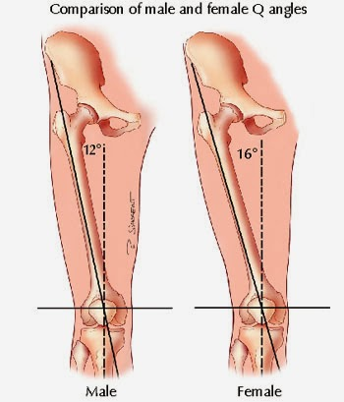
- Compare the shapes of the openings in the center of each pelvis. Record in the table which pelvis has the larger opening, and which has the smaller.

- Locate the letter d on each diagram. Record in the data table whether the bones on the bottom of the pelvis meeting at the letter d form a point or a curve. Record your results in the data table under “Bottom Shape.”

- Compare the position of the femur bones. Femurs connect to the pelvis differently in males when compared to females. Record whether the femurs come straight down from the pelvis, or whether they slant inward.

- Examine the “unknown” pelvis diagram. Make the same measurements on this pelvis diagram as you did on the other two, recording results in millimeters in the data table.

- Repeat steps 4 to 6 using the unknown diagram again. Record results. Determine if the pelvis is from a male or female. Complete the data table with this information. Examine the human skeleton sample(s) in the classroom (if available), and compare it/them with the skeleton diagrams you examined today. Determine the gender of the classroom skeleton. GENDER: ____________, and record in data table.

- Answer all the discussion questions on page 4.

- Students will present their findings of the difference between male and female skeletal structures and their hypothesis on the purpose of those variations in a written conclusion. Students will conduct research to establish if their hypothesis were accurate or not.
C | 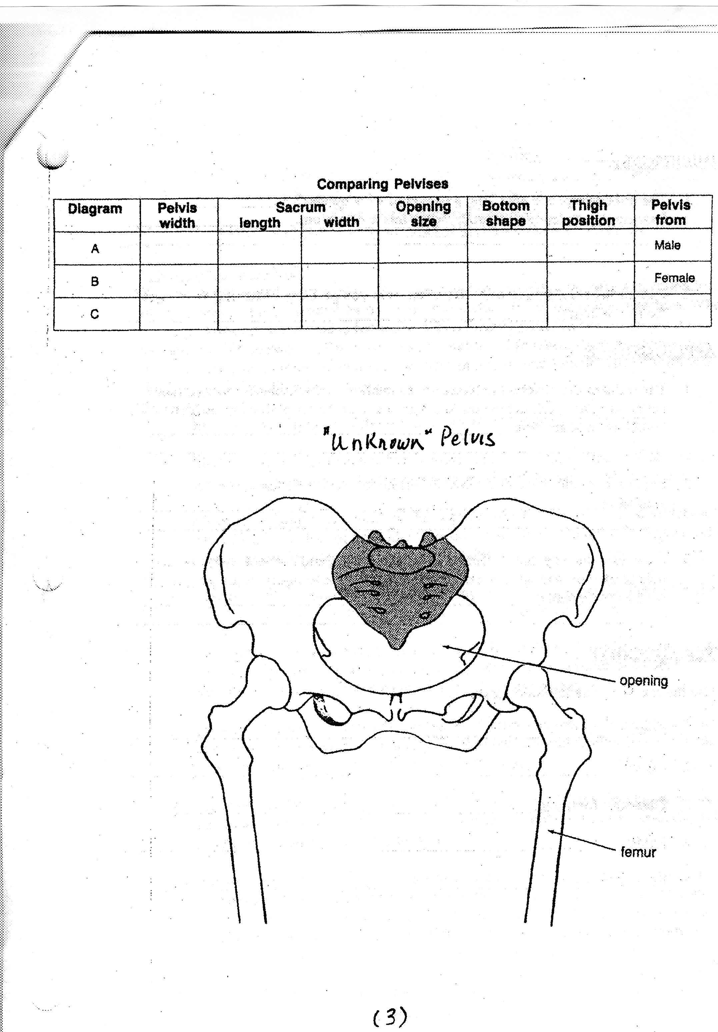
Side Study: Male Vs Female center of gravity study – See teacher for class demonstration.
- Draw and Explain Experiment below:

A | 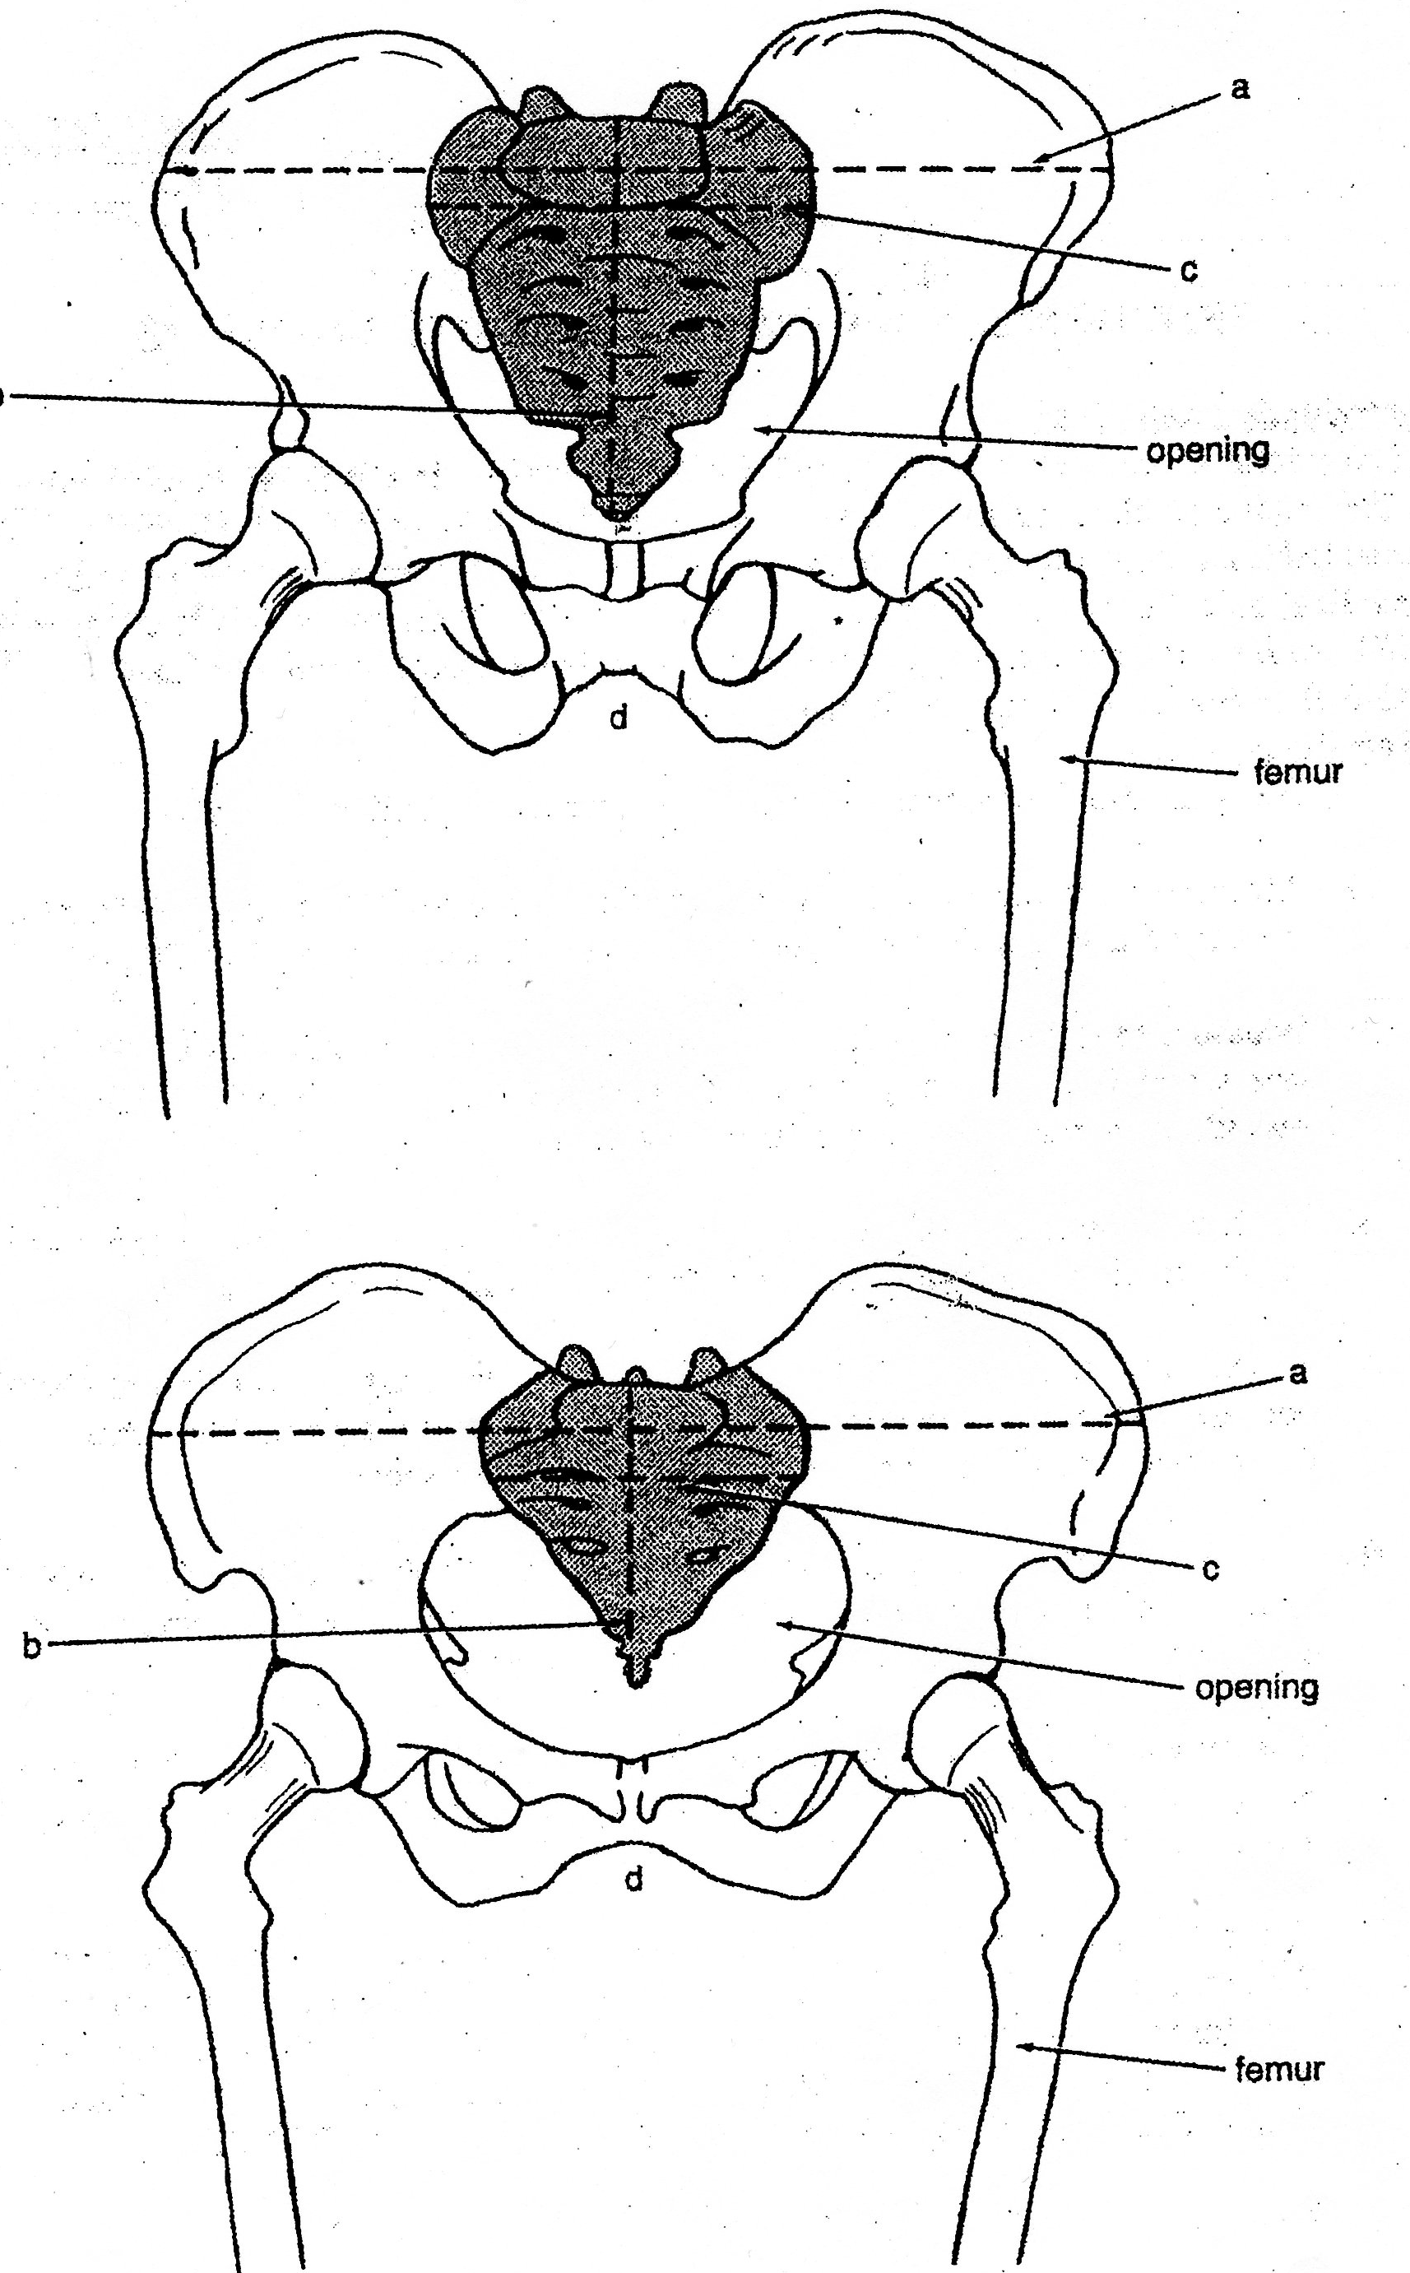
B

QUESTIONS:
1. The unknown pelvis was from a person of what gender? ___________________________________________________________________
Discuss the evidence that you have for this assumption:
________________________________________________________________________

________________________________________________________________________

___________________________________________________________________
2. Explain what information about the skeleton you get from observing the slant of the femur bones:
________________________________________________________________________

________________________________________________________________________

________________________________________________________________________

APPLICATIONS:
1. The traits of the different pelvises are adaptations, which enable an organism to better survive. Explain how the size and shape of the OPENING in the pelvis of a female is an adaptation: _________________________________________________________________________

_________________________________________________________________________

________________________________________________________________________

________________________________________________________________________

2. Explain how the shape of the SACRUM in the pelvis of a female is an adaptation:____
________________________________________________________________________

________________________________________________________________________

________________________________________________________________________

3. How does the way that the femur bones align with, and connect to the pelvis help to explain why girls are often more susceptible to injury in jumping sports, such as volleyball?_______________________________________________________________
________________________________________________________________________

________________________________________________________________________

________________________________________________________________________
VOCABULARY: Structure and Function
Use the text to define the following:
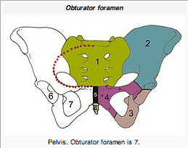

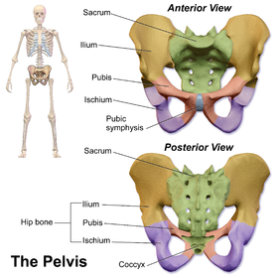

1. Sacrum (#1):_____________________________
- Purpose: ______________________________
______________________________________
______________________________________

2. Coccyx (projection under #5) :_____________________________________________
- Purpose: ____________________________________________________________

__________________________________________________________________

3. Obturator Foramen (#7):_________________________________________________
- Purpose: ___________________________________________________________

__________________________________________________________________

4. Pubis:________________________________________________________________
- Purpose: ___________________________________________________________

__________________________________________________________________

5. Pubic Symphysis (#5): ___________________________________________________
- Purpose: ___________________________________________________________

__________________________________________________________________

