Blood Type Research
Chapter 13
Research (about 1/2 a page of notes) on what blood type and the different blood types are, including Rh (+/-) factors.

Possible tools:
- VIDEO: https://www.youtube.com/watch?v=KXTF7WehgM8
- VIDEO: https://www.youtube.com/watch?v=e62ClW7H15I
- http://www.redcrossblood.org/learn-about-blood/blood-types
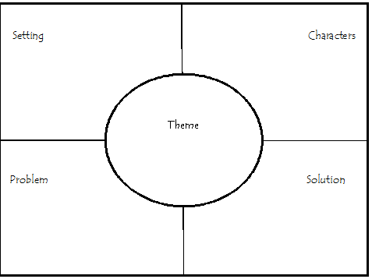
7.1 Introduction
- Bone

- Ske

