Mendelian Genetics II – Dihybrid Crosses
Environmental Impact on Phenotype

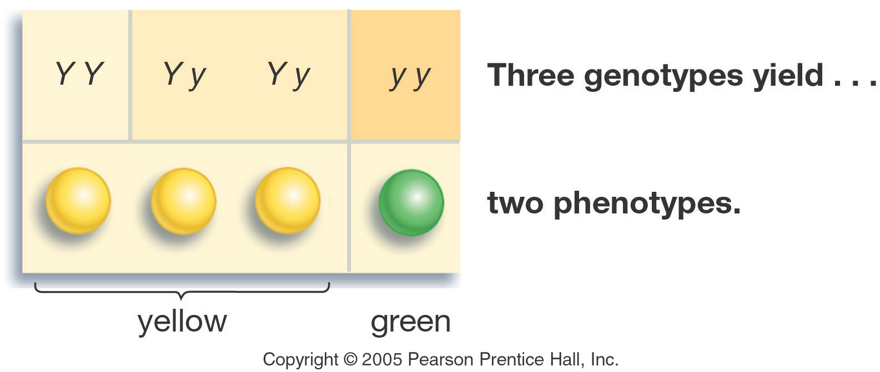

- ________: of the soil will change the color of hydrangea flowers from blue to pink
- Temperature: ___________________________________________________
Generation “Gap”
- Parental _________ Generation = the parental generation in a breeding experiment.
- F₁ generation = the first-generation offspring in a breeding experiment. (1st filial generation)
  - From breeding individuals from the P₁ generation
- __________generation = the second-generation offspring in a breeding experiment.
(2nd filial generation)
  - From breeding individuals from the F₁ generation
Mendel’s Laws - Laws of Inheritance
- Law of ____________________: When gametes (sperm egg etc…) are formed each gamete will receive one allele or the other.
- Law of independent ______________________________: Two or more alleles will separate independently of each other when gametes are formed
Results of Monohybrid Crosses
- Inheritable factors or genes are responsible for all heritable characteristics
- Phenotype is based on _____________________
    - Which of these does natural selection act on?_____________________
  - Each trait is based on two genes, one from the mother and the other from the father
  - True-breeding individuals are ___________________ (both alleles) are the same
Law of _____________________
- In a cross of parents that are pure for contrasting traits, only one form of the trait will appear in the next generation.
- All the offspring will be heterozygous and express only the ____________________ trait.
- RR x rr yields all Rr (round seeds)
Law of Segregation
- During the formation of gametes (eggs or sperm), the two alleles responsible for a trait _____________________ from each other.
- Alleles for a trait are then "______________________" at fertilization, producing the genotype for the traits of the offspring.
Applying the Law of Segregation

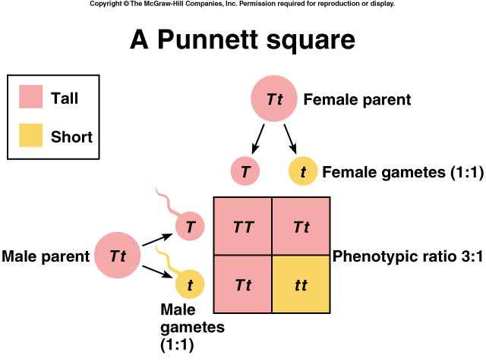

Use the Foil Method:
First
Outside
Inside
Last

Law of Independent Assortment
- Alleles for ______________________ traits are distributed to sex cells (& offspring) ____________________ of one another.
- This law can be illustrated using dihybrid crosses.
Dihybrid Cross
- A breeding experiment that tracks the inheritance of two traits.
- Mendel’s “Law of Independent Assortment”
- Each pair of alleles segregates independently during gamete formation
Dihybrid Cross
Traits: Seed shape & Seed color
Alleles:
R round
r wrinkled
Y yellow
y green

Dihybrid Cross | Summary:  Phenotypic Ratio  Genotypic Ratio
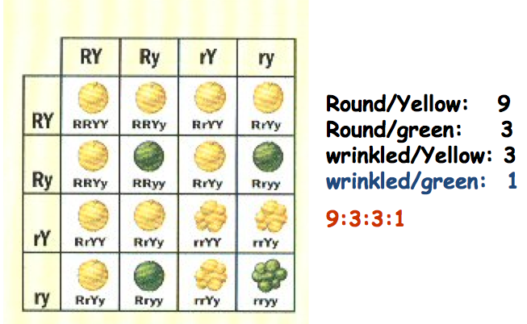
Summary of Mendel’s laws

