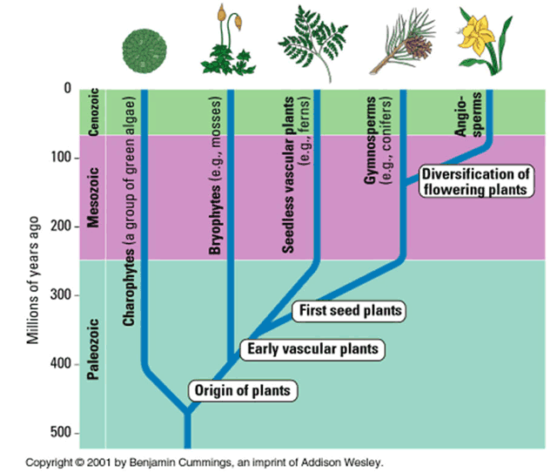
Plant Essay: Introduction Paragraph Outline & Note Sheet
Introduction Outline | ☐ What is the paper about:  ☐ Phylogenetic tree  ☐What is it:  ☐What does it show:  ☐How does it show that:  ☐ Characteristics of plants:  - What does this mean?  ☐Chloroplasts  ☐ Cell wall  ☐Photosynthesis  ☐ Connection to the rest of the food web:  ☐ What is a food web  ☐ Where are plants in the food web?  ☐ What role do they perform?  ☐ What would happen without them?

