Butterfly Life Cycle Notes
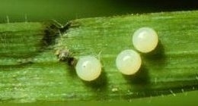

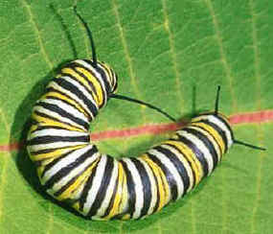

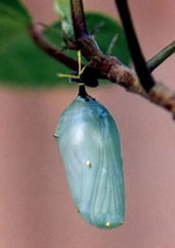

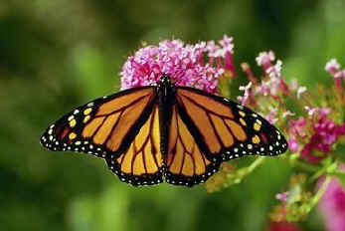

Why the crazy colors on the caterpillar and the butterfly?

Where do they get the toxin?

Toxins and Learning

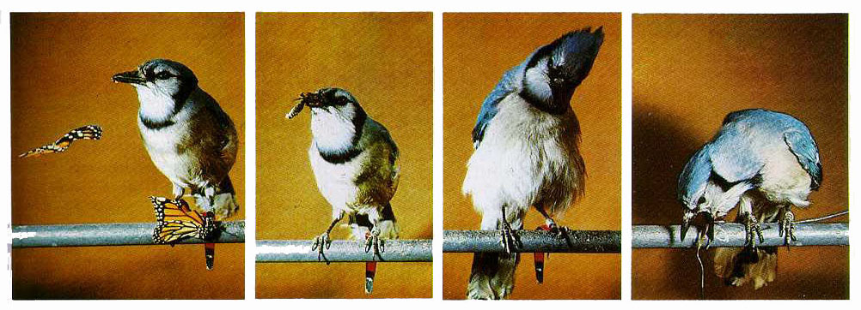
Cool article about the blue jay: http://www.sciencefriday.com/blogs/04/18/2013/the-case-of-the-barfing-blue-jay.html

