Project:
Skeletal Disorder Pamphlet Presentation
- What the assignment is: Students choose a disorder of the skeletal system and create an informational pamphlet on the disorder.
- What the students will be doing: Each student designs informational pamphlets that will describe in detail, the condition, what the symptoms of the condition are, who is affected by the condition, what the treatment/cure is (if any), current research on the condition and any other interesting facts.
- Purpose of the assignment: The assignment is a jigsaw activity where students will become an expert on one skeletal condition and learn from the presentation of their peers about several other conditions. The ultimately purpose of the activity is for students to become experts in one condition of interest and understand how it varies from a non-afflicted skeletal system.

Title of Disorder

Graphics
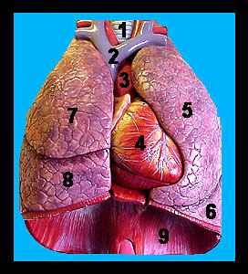

Description
of disorder

Symptoms

Who is Affected?
Treatments

Cures

Current research

Interesting Facts
Hotline!

Contacts

Further Information
- What the final product will be: Students will generate a pamphlet on skeletal condition that includes a description of the condition and how it varies from a healthy skeletal system, what the symptoms of the condition are, who is affected by the condition, what the treatment/cure is (if any), current research on the condition and any other interesting facts. Students will take notes on other student’s presentations that will serve as notes for a quiz on skeletal conditions.
- What the final product will be graded on:

Pamphlet Design: /5

Presentation: /5

Description: /5

Symptoms: /5

Who is affected: /5

Treatment: /5

Cure: /5

Current research /5

Interesting facts: /5

References (3): /5

One has to be a scientific article

Acting out of Disease /10

TOTAL /60

