Fish Ecology Notes
Anadromous

- ___________ ____________ _________ Estuary ______________

- Q: Why do they have to stop in estuarine habitat on the way out to sea and the way back?

Habitat

- Freshwater Estuary Marine Estuary Freshwater
______________ _______ & Salt Fresh & Raparian
Creek _________Mixed Salt Mixed Creek
5 Native Species of Salmon:
Chinook, Chum, Pink, Coho, Sockeye

______________ | ____________ | Steelhead _____________ | ________________ trout
- Chinook are the ____________ of the 5 native Pacific Salmon species. They are also called “King” Salmon.  - Winter-run: Federally and State listed ______________  - Spring-run: Federally and State listed _______________ | - Coho salmon are no longer present in the Central Valley Rivers (______________).  - Federally Threatened  - State Endangered | - Steelhead and Rainbow trout are the same species of fish. If they become ________________, they are steelhead, if food is abundant in their river, they will remain resident and are  - Federally threatened | If the fish ________________ in it’s freshwater home river and leads a non-anadromous life, it is a Rainbow trout.  If the fish travels to the ocean and becomes anadromous, it becomes a Steelhead  Steelhead will convert to rainbow trout if:  - It’s a ________________ year  - Their river becomes __________  - There is ___________ ___________ in the stream  WHAT IS THE BENEFIT: This allows for this species to be more ____________________ to  changing environmental

Migration
What is it:
Best described by a series of traits:
1.Persistent prolonged ____________
2._________________ by usual stimuli (e.g. food, mates)
3.Distinct ____________ and _____________ behavior
4.Reallocation of _____________ in advance of migration

Energy - How do Salmon Power their Migration?
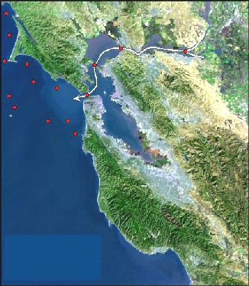
- Early in migration: use mostly ___________
- Later in migration: fat is depleted, use protein from breaking down (___________________) their gut, then _______________ muscle. Protect red muscle and heart.
Why don’t all the salmon migrate to the same place?

What 2 factors help them know where to go? (http://www.youtube.com/watch?v=5DqjsWsY8-g)
1)

2)

Debbie Downer: Salmon are more imperiled in California than any other western state. Salmon are vital to California’s ecology and economy, including a $1.5 billion commercial and recreational fishing industry. One of the key threats is a lack of information on the number of spawning salmon in California coastal waters. (Ref)

