Fish Ecology Notes
Anadromous

- Freshwater Estuary Marine Estuary Freshwater

- Q: Why do they have to stop in estuarine habitat on the way out to sea and the way back?

Habitat

- Freshwater Estuary Marine Estuary Freshwater
Riparian Fresh & Salt Fresh & Raparian
Creek Salt Mixed Salt Mixed Creek
5 Native Species of Salmon:
Chinook, Chum, Pink, Coho, Sockeye

Chinook | Coho | Steelhead TROUT | Rainbow trout
- Chinook are the largest of the 5 native Pacific Salmon species. They are also called “King” Salmon.  - Winter-run: Federally and State listed Endangered  - Spring-run: Federally and State listed Threatened | - Coho salmon are no longer present in the Central Valley Rivers (extirpated).  - Federally Threatened  - State Endangered | - Steelhead and Rainbow trout are the same species of fish. If they become anadromous, they are steelhead, if food is abundant in their river, they will remain resident and are  - Federally threatened | If the fish stay in it’s freshwater home river and leads a non-anadromous life, it is a Rainbow trout.  If the fish travels to the ocean and becomes anadromous, it becomes a Steelhead  Steelhead will convert to rainbow trout if:  - It’s a drought year  - Their river becomes blocked  - There is ample food in the stream  WHAT IS THE BENEFIT: This allows for this species to be more adaptable to changing environmental

Migration
What is it:
Best described by a series of traits:
1.Persistent prolonged movement
2.Undistracted by usual stimuli (e.g. food, mates)
3.Distinct departure and arrival behavior
4.Reallocation of energy in advance of migration

Energy - How do Salmon Power their Migration?
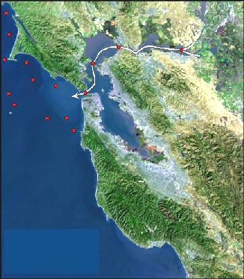
- Early in migration: use mostly fat
- Later in migration: fat is depleted, use protein from breaking down (catabolizing) their gut, then white muscle. Protect red muscle and heart.

Why don’t all the salmon migrate to the same place?

What 2 factors help them know where to go? (http://www.youtube.com/watch?v=5DqjsWsY8-g)
1)

2)

Debbie Downer: Salmon are more imperiled in California than any other western state. Salmon are vital to California’s ecology and economy, including a $1.5 billion commercial and recreational fishing industry. One of the key threats is a lack of information on the number of spawning salmon in California coastal waters. (Ref)

