Respiratory Volumes and Capacities Homework
Examine this chart, define the components and explain the overall meaning of this chart:
Fig1: Lung Volume Measurements
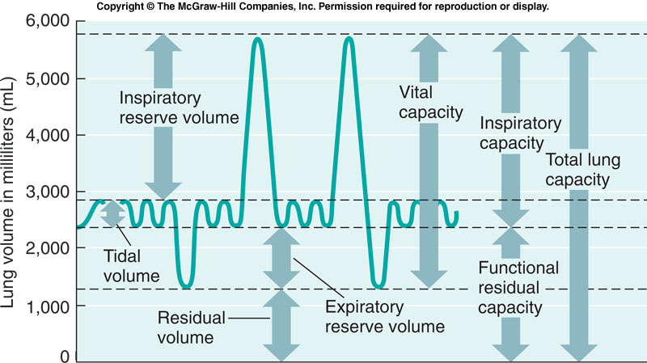

Tidal volume(TV)-
Inspiratory Reserve Volume (IRV) -
Expiratory reserve volume (ERV)-
Residual volume (RV)-
Vital Capacity (VC)-
Inspiratory Capacity (IC)-
Functional Residual Capacity(FRC)-
Total Lung Capacity (TLC)-
Overall what is this chart show

\

