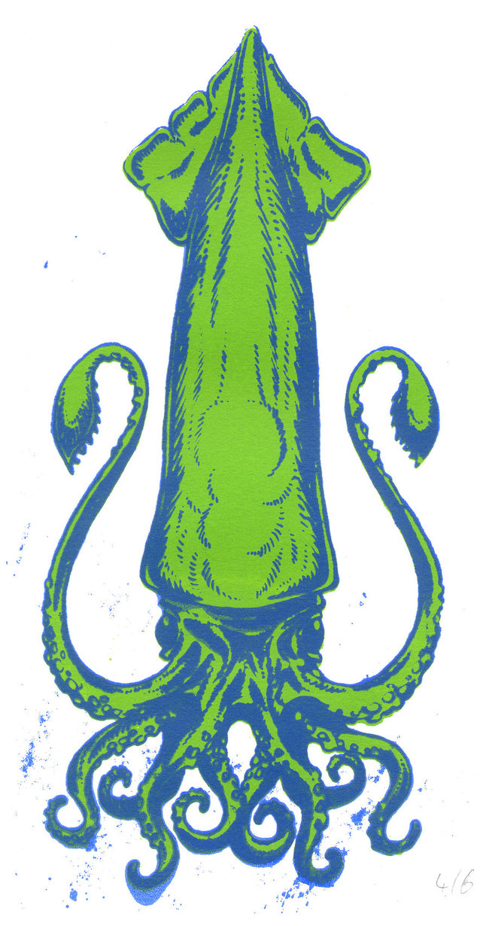
Lab: Squid Prints!
Aquatic Adaptations

Theme: Connect structure to function.

Goal: Using the structure of a squid, identify the adaptations in its morphology and what environments it is likely to live in.

Directions:
- Take defrosted squid out on plate
- Lay out the squid in a natural way
- Place paint the top surface of the squid with paint – be creative!
- Place card stock on the squid and apply pressure – don’t squish the squid!
matt-walkden.deviantart.com
- Remove paper and examine print
- Label the parts of the squid
- Identify 3 adaptations on the squid – draw them onto the print
- Using the adaptations, identify what habitat this animal is adapted to – write it below
- Complete the sections below
Habitat: (Be specific about which biome this animal lives in)

Summary: (Write a summary of how this animal is adapted to this biome)

Structure and Function: (How does an animal’s structure connect to its function?)

