Kidney Paper:

- Fill in blanks and type = 75%
- Reorganizing +10%
- Adding Material + 15%
Paragraph1: Introduction:
- Explain homeostasis:
- Explain water balance in terms of homeostasis:
- Introduce the Kidneys role in water balance:
- Where is it located
- What organisms have it?
Evolution of Water Balance:
- Paramecium (unicellular)
- Planaria (multicellular)
- Insects
- Fish
  - Fresh
  - Salt
- Amphibian
- Reptiles
- Birds:(salt glands)
- Mammals:
Vertebrate Kidney Form
- Discuss function of each piece
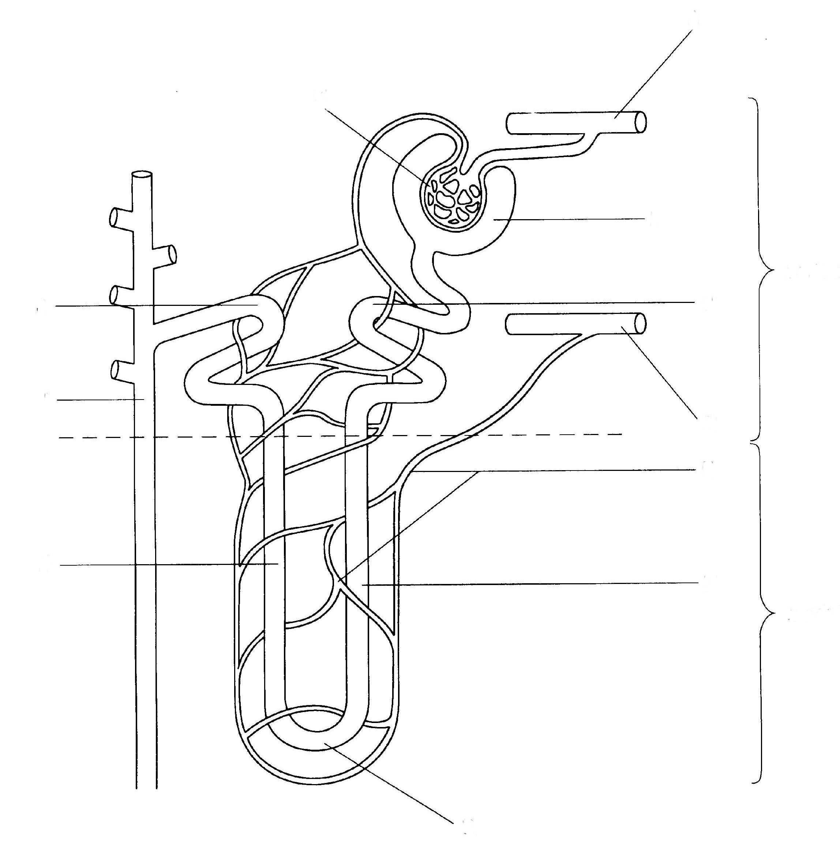
Conclusion:
- Implications if a kidney fails
- Why would it be better to drink pee than let your kidney stop having something to filter?
Use:
- 1 figure
  - Reference in text
  - Example: the intricate form of the vertebrate kidney uses loops of henle (see figure 1).
References
- Minimum of 3
- Sited at the end in APA/MLA format
- Sited in Text (consider using a # at the end of the sentence that corresponds to number of the reference in the bibliography) ¹.

