Reading DNA Activity: Mutation Types
What types of mutations can occur in DNA sentences?

- Point mutations are single nucleotide base changes in a gene's DNA sequence. This type of mutation can change the gene's protein product in the following ways:
- Missense mutations are point mutations that result in a single amino acid change within the protein.
- Nonsense mutations are point mutations that create a premature "translation stop signal" (or "stop" codon), causing the protein to be shortened.
- Silent mutations are point mutations that do not cause amino acid changes within the protein.
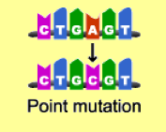
- Insertion mutations and deletion mutations add or remove one or more DNA bases. Insertion and deletion mutations cause frameshift mutations, which change the grouping of nucleotide bases into codons. This results in a shift of "reading frame" during protein translation.
