Reading DNA Activity: Mutation Types
Mutation Big Picture:
What are mutations?

How are they related to evolution?

Are mutations good or bad?

Mutation Catagories:
- Point mutations
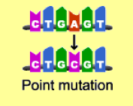
What is it:
Types
- Missense mutations
Describe the mutation:

How does it affect the protein?

- Nonsense mutations
Describe the mutation:

How does it affect the protein?

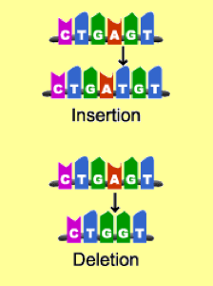
- Silent mutations
Describe the mutation:

How does it affect the protein?

- Insertion mutations and deletion
- Insertion
Describe the mutation:

How does it affect the protein?

- Deletion
Describe the mutation:

How does it affect the protein?

