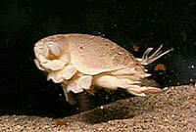
LIMPETS – Sandy Beach Monitoring Program

- Why monitor sand crabs at the beach?

- Life Cycle:
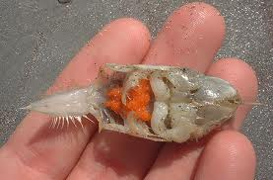
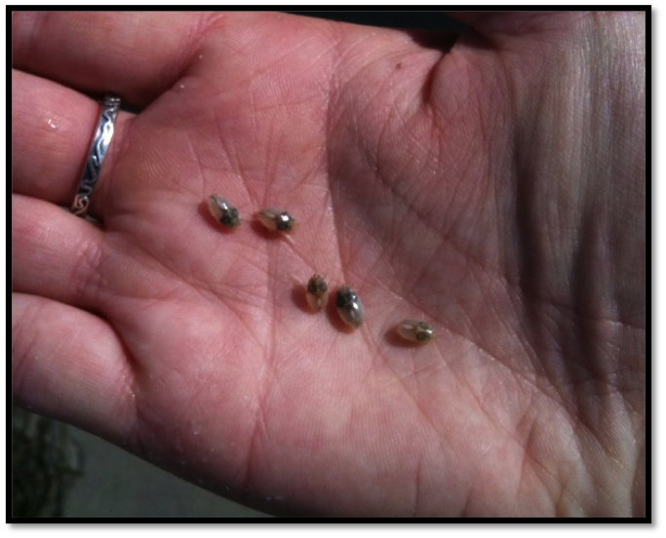
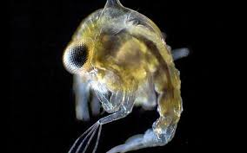

- Draw their food web:

- How is long term monitoring sand crabs helpful for mitigation?

- Scientific Method:
Where do we monitor? | How do we set up the sampling area?
Data Collection:
Collection | Measuring:  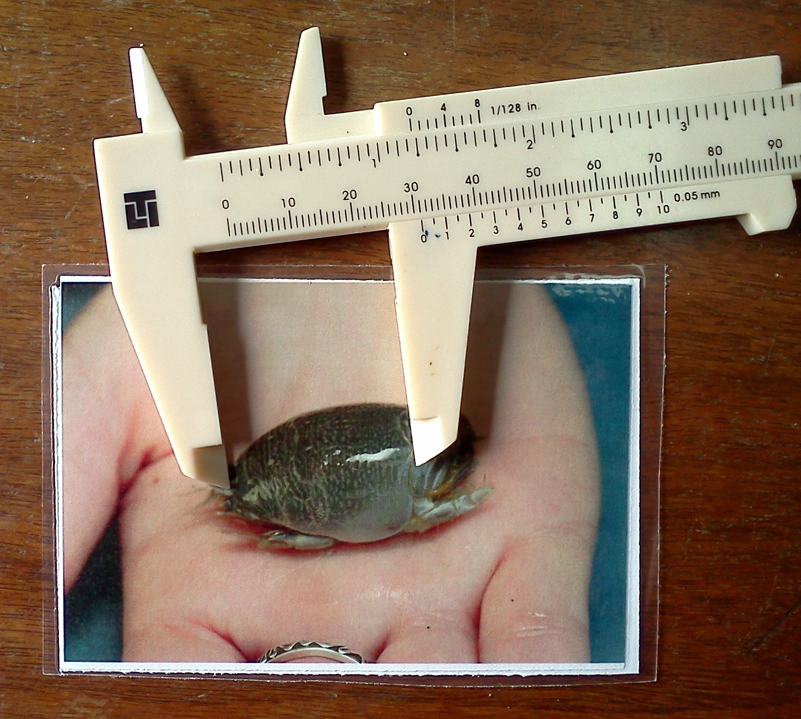
Data Entry:
At the Beach | Online | Importance

