Pro/Euk - Cell Biology COMPLETE Notes
Questions/Pictures/ Key Words

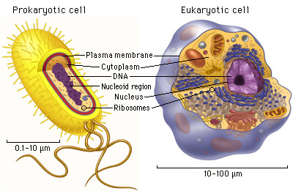

“…” means something the teacher said

Two types of cells:
- Prokaryote Cells
- Eukaryote Cells

Every thing we know about cells we call
“cell theory”.
- Cell Theory says that….
- All living things are made of cells.
- Cells are the basic units of structure and function in all living things. In other words, cells are like the building blocks of all living things.
- New cells are only made from existing cells.

Cells come in all shapes and sizes!
- There are two types of cells:
1) Prokaryotic Cells
2) Eukaryotic Cells

- Big differences between cell types:
STRUCTURAL differences.

Prokaryote Cell: A single celled organism that does not have a nucleus. – “PRO-NO! “
Traits of Prokaryotes: (pro-care-ee-ohts)
1. They do not have a nucleus, and their genetic material
2. They have some organelles, but not many.
3. They are less complicated that eukaryotes.
4. All bacteria are prokaryotes.
•Bacteria is good, who knew?!
    - Decomposers: without them all other organisms would not be able to survive.
    - Needed in digestive system to help digest our food. There are approximately 10x as many bacterial cells as human cells in the human body!
    - Needed for cheese & yogurt
Summary:
Questions/Pictures/ Key Words

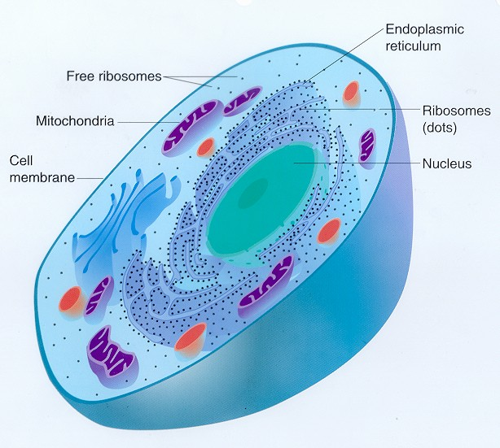

Eukaryote Cell: A more complex cell with a nucleus and many organelles. – “Eu-DO!”
Traits of Eukaryotes: (you-care-ee-othts)
1. They all have a nucleus where the genetic material of the cell is stored.
2. They have many organelles that work together to help the cell function.
3.Eukaryotic cells are much more complex then prokaryotic cells.
4. They can be just one cell or can make up more complex multi-cellular organisms.
5. All plants, animals, fungi, and protists are eukaryotic cells.

Summary: Prokaryotic cells do not have a nucleus
& Eukaryotic cells do have a nucleus.
This allows eukaryotic cells to make multi-cellular organisms and perform more complex functions.

