Pterophytes (Ferns) & Gymnosperms (Conifers)
LAB
►Overview
Last week we looked at nonvascular plants (bryophytes and charophytes). This week, we're studying two major plant groups that have well-differentiated vascular tissue (xylem, which transports water and nutrients, and phloem, which transports sugars and other metabolites).
- The first group, known as seedless vascular plants, consists of two phyla: P. Pterophyta (ferns, horsetails and whisk ferns).
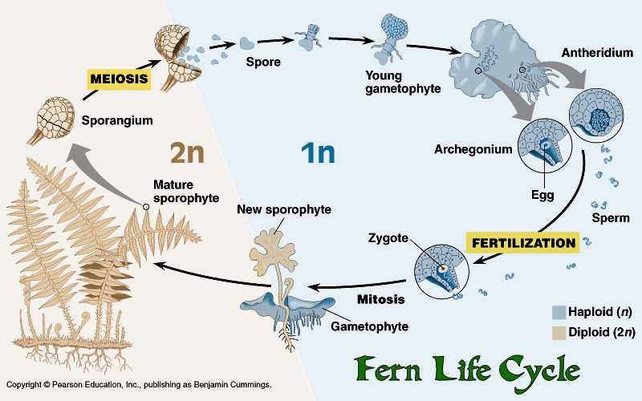
- The second group is the Gymnosperms -- plants that produce seeds, but lack true flowers or fruits. Their most familiar members are the conifers, including pines, spruces and firs, but they also include many more obscure and beautiful plants unfamiliar to most people from North America. Gymnosperms include the tallest, most massive, oldest, and possibly the most beautiful organisms known to humankind.
Gymno- means naked and –sperm means seed. "Naked" here refers to the lack of a fruit surrounding the seed; a fruit is a structure derived from the ovary of a flower, so fruits are found only in the flowering plants (the Angiosperms), which we will study next week.
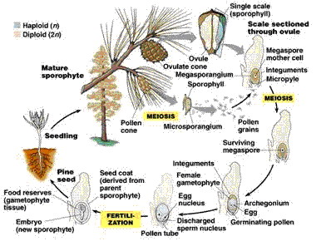
►Station 1: Examine the transport tissue
 | Xylem | Phloem
Draw
Describe Structure
- does one have thicker edges?
Function
- Question: Why are vascular plants able to grow much taller than non-vascular plants?

►Station 2: Sori
1. Take a small piece of leaf from the fern indicated by your instructor make a wet mount of the sore, see if you can see the individual spores
2. Draw the sporangium and some spores below.
Magnification: x

►Station 3: Examine Ferns
1. Observe and compare the live specimens of ferns.
- Fern species are often distinguished by the location of the spores under the leave. The spores are clumped into a structure called a sori (sing. sorus) on the leaf.
Fern Specimen | #1 | #2 | #3
Drawing
Location of Sori
Describe the leaf structure

►Gymnosperms
Types of Gymonosperms:
- Coniferophyta - pines and other cone-bearing gymnosperms
- Cycadophyta - cycads
- Ginkgophyta – Ginkgo
- Gnetophyta - the gnetophytes, a small and strange group
►Station 4: Cone
Examine the structure of a cone and compare it to a flower.
Question: How could a flower have evolved from a cone?
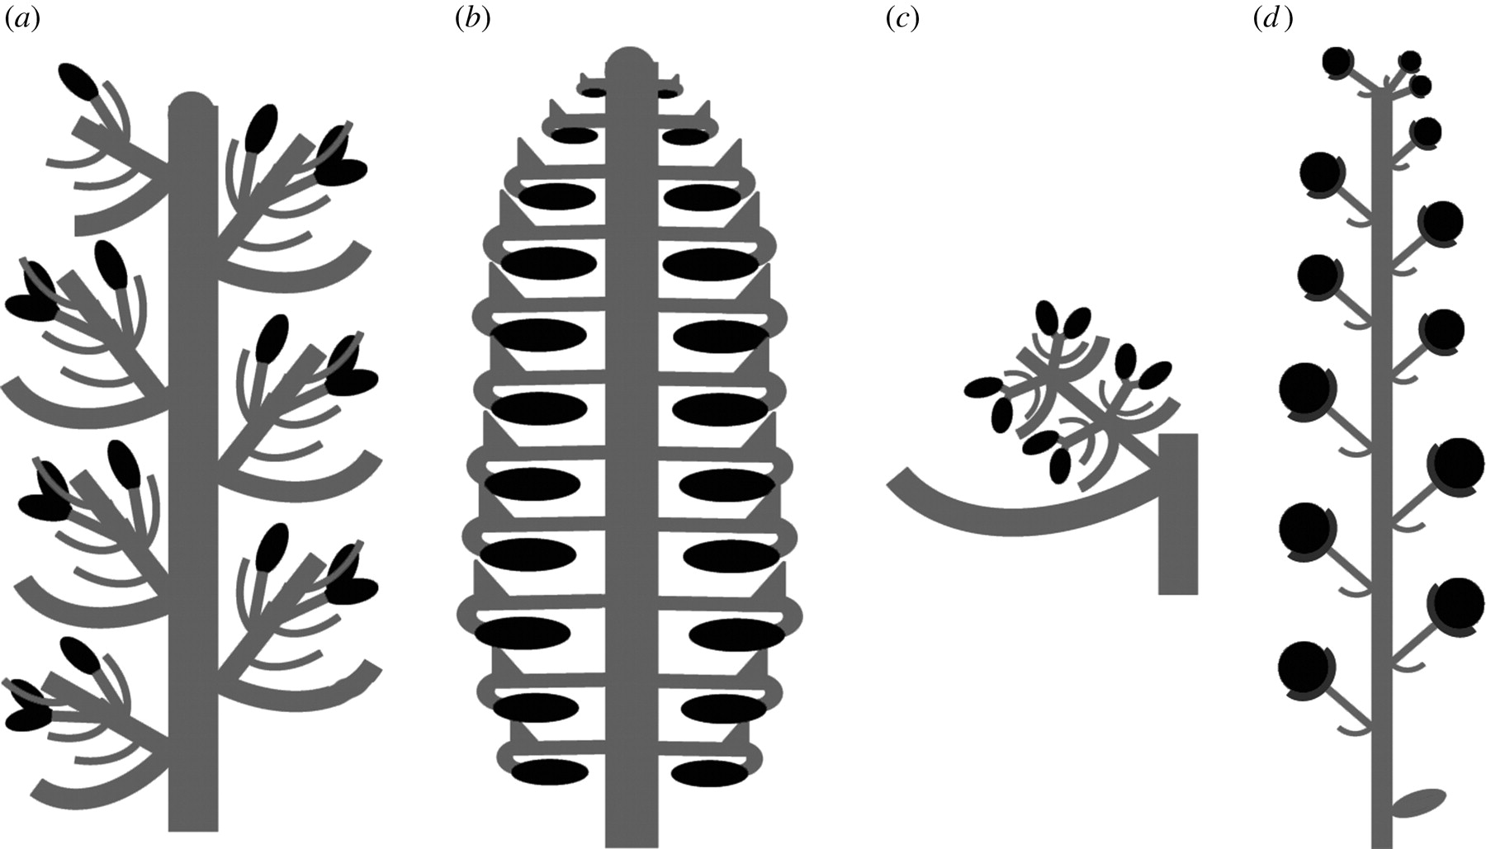
►Station5: Pollen Grain
- Examine the picture of pollen grains.
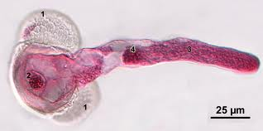
Description of cells | Hypothesize what they do | What they really do  (read below)
1.
2.
3/4

2. Pine pollen consists of a cell and two air bladders for wind dispersal and can travel great distances. Look for germinated pollen with a pollen tube that has grown out of the pollen grain. You can make out the tube nucleus inside the pollen tube. The generative nucleus is found in its own cell in the pollen grain. Once the pollen tube reaches the female egg in an special female cone, the tube nucleus will divide into two sperm cells.
Draw a germinated pollen grain and label air bladders, pollen tube, tube nucleus, and generative nucleus.

STATION 1: TRANSPORT

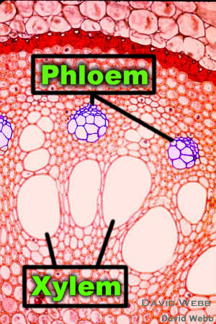

STATION 5: Pollen

Microscopical view of a stained slide of a pine pollen tube.  1 = Air bags or air bladders,  2 = Generative cell with generative nucleus,  3 = pollen tube,  4 = tube nucleus (4) | 