Plant Review

Be able to explain this:

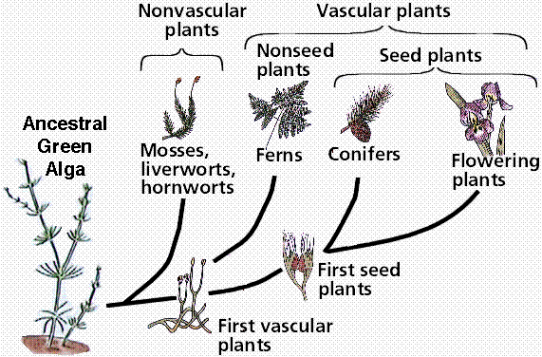

Move to Land

Vascular

Seeds

Flowers

|  |  |
| --- | --- |
| Screen shot 2012-12-07 at 12.57.34 PM.png |  |
|  |
|  |
|  |
|  |