STD Transmission Lab
Purpose: To measure the rate at which the Human Immunodeficiency Virus (HIV) may spread through a community.
- Each person will receive a vial representing his or her "body fluid".
- One of the vials will be "infected" with HIV (not the real virus!) and the class will engage in "test tube sex".
- The spread of the virus will be measured after sex.
Materials:

- 1 paper towel labeled with name
- 1 small test tube, about 1⁄2 full of “body fluid”
- 1 dropper inserted into test tube
- 2 clean, dry glass slides (labeled: 0, 1, 2,3)
- Handouts and writing utensil

Procedures for spreading the virus:
- Each student should get their materials & set their slides on the spaces provided on the data sheet
(NOTE: Some of the "body fluid" solutions will contain a strong base, NaOH. Do not squirt fluids at other students. Please report all spills).

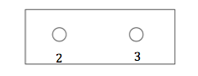
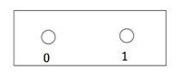
- Set- up:
- Label the first slide (0, 1) and the second slide (2,3)
- Put slides on your paper towel
- Right your name on your paper towel

- Pretest for HIV:
- Place one drop of your "body fluid" solution on slide #0.
- Place the slide on the data sheet to the right of item #0 for later testing.

- Spreading the infection: Each person will exchange body fluid with a total of three other people. We will test the body fluid for HIV after each sexual contact. Do steps A, B and C below to complete round #1.
  - Find a student (of either sex) to "exchange" body fluid with. Do this by having you and your partner each suck up to the 0.5 mark (1/2 way up the dropper’s tube) of fluid with your dropper. Place this dropper amount from your test tube into your partner's test tube at the same time your partner puts their dropper full of fluid into your test tube. We will call this "test tube sex".
  - Put your thumb over the top of the test tube and invert it twice to mix the contents.
  - Place ONE DROP of fluid from your test tube onto slide #1.
  - Place the slide on the data sheet for later testing.
  - Write down the name of the person you had "sex" with on item #1 of your data sheet.

- Have “test tube sex" with two new people.
- After person #2, place one drop of your test tube contents on slide #2.
- Place slide #2 on the data sheet for later testing.
- After person #3, place one drop of your test tube contents on slide #3.
- Place slide #3 on the data sheet for later testing.
Be sure to write down the names of each person you had test-tube sex with!

- Testing for Infection: Place one drop of phenylethylene on each slide, right on top of your body fluid samples.
- Solution remains clear or turns yellow = not infected
- Solution turns red or pink = infected (sorry!)

- Complete your data sheet. Answer questions 1-7, and the back of the data sheet.
- Clean, dry, and return slides and other materials when done.
How to test for the virus:
I. Place one drop of phenylethylene on each slide, directly on top of your body fluid.
- Be careful NOT to touch the phenylethylene dropper to the body fluid.
2. If your solution remains clear or turns yellow... you are NOT infected. Phew.
3. If your solution turns red or pink ... sorry ... you have HIV!
- NOTE: If you are not sure of your reaction results, carefully mix the solution with you pencil tip. Be careful not to spread to other drops. Ask your teacher for help.
Clean up and final work:
1. Complete your data sheets.
2. Rinse well and dry your slides. Return slides to designated area.
3. Answer all questions neatly on separate piece of paper, and keep for class discussion.
HIV/AIDS Simulation Lab
Student Worksheet
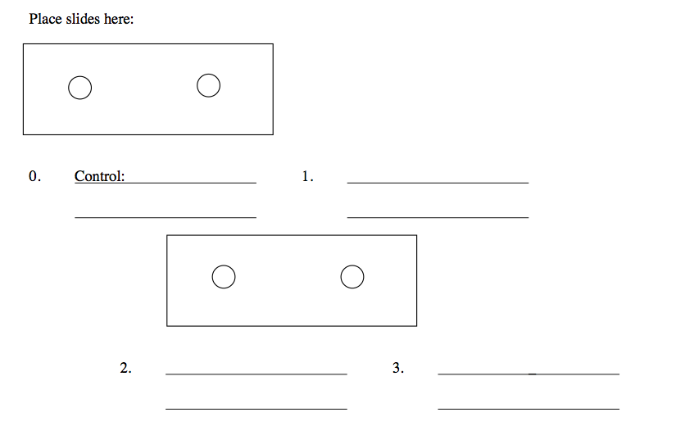
0
1
3
2
Answer the following questions on a separate piece of paper:
1. Did every person in the room become infected? Why/why not?
2. If we continued to do this activity, would everyone eventually get HIV? Explain.
3. During the spread of a real viral infection not everyone in the community will get the disease no matter how long it lasts. What might be some explanations for this?
- Include the word immunity in your answer.
4. Name at least two other viral diseases besides HIV/AIDS.
5. What is the difference between viral and bacterial STD/STI’s?
6. IF you did get infected during the activity you should be able to figure out who gave you the virus. Find their name on your data sheet and fill in the following information: I caught the virus in round # _____. The person who gave it to me was_______
7. Discuss at least two ways the spread of HIV/AIDS can be prevented.
8. What is the difference between HIV and AIDS?
9. What does a person with HIV look like? Can you recognize someone with this virus?
Data Sheet
Slide #0 = Pretest for STD  Place the slide to the right.  A) Results of testing: Final color after adding phenylethylene?_________ infected?_______  B) If you were infected at this stage you were the original carrier. Please place your name on the board. | *slide with one drop of body fluid before having sex
Slide #1 = Sexual Contact with 1  - Slide #1. First round of contact.  Name of first contact:_______________  Place the slide to the right.  A) Results of testing: Final color after adding phenylethylene?___________ infected?________ | *slide with one drop of body fluid after having sex with one person
Slide #2 = Sexual Contact with 2  2. Slide #2. Second round of contact.  Place the slide to the right.  Name of contact:________________  A) Results of testing: Final color after adding phenylethylene?__________ infected?_________ | *slide with one drop of body fluid after having sex with two people
Slide #3 = Sexual Contact with 3  3. Slide #3. Third round of contact.  Place the slide to the right.  Name of contact:________________  A) Results of testing: Final color after adding phenylethylene?___________ infected?_________ | *slide with one drop of body fluid after having sex with three people

Class Data Table: please put your data on the board, complete table when all students have reported.
 | Starting  Round #0 | First  Round #1 | Second  Round #2 | Third  Round #3
Number of persons infected
Total persons in room
Theoretical number of infections | 1 | 2 | ? | ?

WHAT EVERYONE SHOULD KNOW REGARDING HIV/AIDS
WHAT IS AIDS?
AIDS (Acquired-Immune Deficiency Syndrome) is a disease triggered by the Human Immunodeficiency Virus (HIV) which weakens the immune system and attacks cells of the brain.
BODY FLUIDS THAT MAY TRANSMIT HIV IF INFECTED
1. Blood
2. Breast Milk
3. Semen
4.Vaginal Secretions
TRANSMISSION CAN OCCUR WHEN THESE FLUIDS ARE EXCHANGED. THESE ARE THE RISKY BEHAVIORS AS FOLLOWS:
1. Having sex with an infected individual (either vaginal, anal or oral intercourse).
2. Sharing IV drug needles or uncleaned needles (tattoo, ear piercing, etc.)
3. An infected mother can pass the virus on to her baby during pregnancy or while nursing.
-Anyone engaging in risky behaviors can become infected regardless of gender, sexual orientation, age or race.
AIDS IS FATAL, but preventable because HIV IS HARD TO GET!
o SAFE BEHAVIORS include casual contact such as hugging, sneezing or sharing bathrooms.
o TRANSFUSIONS are VERY SAFE because the blood is screened.
o DONATING blood is and always has been SAFE.

PEVENTION FROM BECOMING INFECTED SEXUAL TRANSMISSION
    - Abstinence is one way to absolutely avoid HIV.
REMEMBER most people infected with HIV have no symptoms – they look healthy, so you cannot tell by just looking.
    - Condoms used properly from beginning to end of all sexual activity, will reduce the risk of passing HIV
INJECTABLE DRUGS
    - Not using injectable drugs will prevent the spread of HIV.
HIV /AIDS
