HIV /AIDS
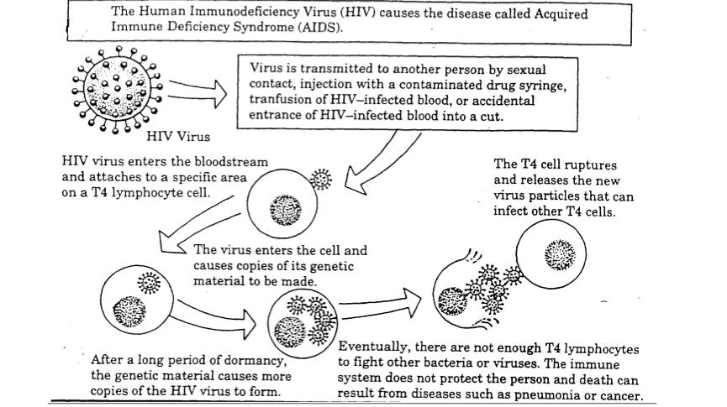
In Class Questions:
1. Why is the transmission of HW by blood transfusions now very rare?
2. What happens when the HIV virus enters the bloodstream?
3.
a. What is the usual function of a lymphocyte?
______________________________________________________________________
b. What happens when the lymphocyte attacks the HW virus?
______________________________________________________________________
4. Describe what occurs within the T4 cell.
5. Why might a person think that they did not get infected with the HIV virus?
6. How does the name AIDS describe the action of the disease?
7. Why do people who inject drugs have a high risk of acquiring AIDS? ______________________________________________________________________

