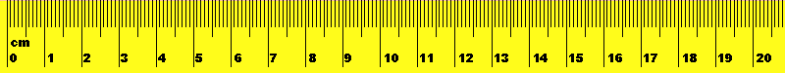
Monarch Caterpillar Observation Sheet
Obs # | Date | Observations size, number, activity level, plant quality | #
1 |  |  | 1mm  2-5mm  6-10mm  1cm-2cm  2-5cm  5-10cm  Chrysalis  Butterfly
2 |  |  | 1mm  2-5mm  6-10mm  1cm-2cm  2-5cm  5-10cm  Chrysalis  Butterfly
3 |  |  | 1mm  2-5mm  6-10mm  1cm-2cm  2-5cm  5-10cm  Chrysalis  Butterfly
4 |  |  | 1mm  2-5mm  6-10mm  1cm-2cm  2-5cm  5-10cm  Chrysalis  Butterfly
5 |  |  | 1mm  2-5mm  6-10mm  1cm-2cm  2-5cm  5-10cm  Chrysalis  Butterfly

6 |  |  | 1mm  2-5mm  6-10mm  1cm-2cm  2-5cm  5-10cm  Chrysalis  Butterfly
7 |  |  | 1mm  2-5mm  6-10mm  1cm-2cm  2-5cm  5-10cm  Chrysalis  Butterfly
8 |  |  | 1mm  2-5mm  6-10mm  1cm-2cm  2-5cm  5-10cm  Chrysalis  Butterfly
Journal Entry:
Include trends in observations, lengths of time to complete development, what you noticed about how quickly they grew, how much they ate, if any got sick and died, about the plant milkweed.

