***Pathogen Notes - (#8)***

TOC #8

Comments/Questions

|  |  |  |
| --- | --- | --- |
| **Guide to infectious Pathogens (“Disease Causers”)** | | |
| Viruses:  (not alive) | Bacteria:  (Prokaryotes) | Protists/Fungi  (Eukaryotes) |
| Screen shot 2012-03-04 at 9.59.36 PM.png | Screen shot 2012-03-04 at 10.00.19 PM.png | Screen shot 2012-03-04 at 10.00.46 PM.png |
| protein coat  ________ or________  That’s all! | cell membrane  maybe cell wall  DNA in nucleus DNA -***______________*** ribosomes |
| Very small | ~ 5 mm | ~100 mm |
| no cure (vaccines) | antibiotics  cure | *invented*  antibiotics |
| Screen shot 2012-03-04 at 10.08.20 PM.png | Screen shot 2012-03-04 at 10.08.47 PM.png | *Screen shot 2012-03-04 at 10.09.22 PM.png* |

1. Prokaryotes:
2. 2 kingdoms, Eubacteria and Archeabacteria.

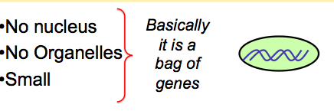

•Evolved ~ ____________________ years ago

•Some require oxygen (O2) some do not

Summary