***Pathogen Notes - (#8)***

TOC #8

1. Eubacteria:

* **Cell Walls**
  1. two types
     1. Gram stain (+) or (-)
     2. Gram-negative do not respond to antibiotics
* **Shapes**: spherical (“cocci”), spiral, rod-
* **Reproduction:** DNA duplicates, cell divides

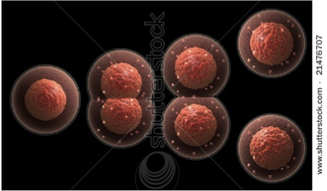

* **Nutrition:**
  + *Autotrophs* (make own food by *photosynthesis or chemosynthesis)*
  + *Heterotrophs (food made by others)*
* **Roles:**
  + decomposers
  + N2-fixers
  + yoghurt
  + cheese, etc.
  + Food contamination:
    - salmonella & botulism!
* Sanitation, heat, cold, vaccination and antibiotics our best defenses
  + (blue-green bread mold makes penicillin, an antibiotic.)

C. Viruses:

* Not alive. Not cells
* Reproduce by taking over a cell’s nucleus and ribosomes
* Vaccines won’t work if virus mutates quickly
* Antibiotics don’t work at all against viruse

Summary

Comments/Questions

