***Pathogen Notes - (#8)***

TOC #8

Comments/Questions

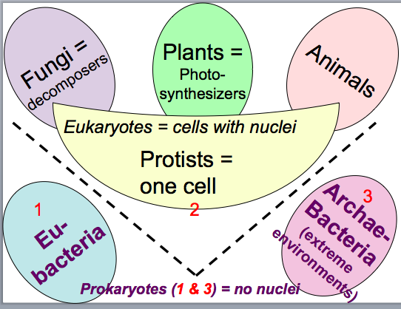

C. Viruses:

* **How do viruses work?**

|  |  |
| --- | --- |
| Screen shot 2012-03-04 at 10.24.02 PM.png | Screen shot 2012-03-04 at 10.24.30 PM.png |
| Screen shot 2012-03-04 at 10.25.34 PM.png | Screen shot 2012-03-04 at 10.26.00 PM.png |
| Screen shot 2012-03-04 at 10.26.26 PM.png |  |

D. Eubacteria: ( 4 kingdoms: Animals, Plants, Fungi, Protists.)

|  |  |
| --- | --- |
| •Have nuclei  •Have many organelles  •Big  •Evolved ~1 billion years ago  •Require O2 | Screen shot 2012-03-04 at 10.28.03 PM.png |

Summary