Immune System Notes
TOC #15
Immune System:
•Immunity:

–Function: Fight infection through the production of cells that inactivate foreign substances or cells.
•Immune System Notes: Nonspecific
A. Nonspecific Defense:
•First line of nonspecific defense:
•Hard-to-penetrate skin!
•Keep things out
•Mucous membranes (sticky)
•Trap things
•Second line of nonspecific defense:
•Inflammation: Heat (Fever)
•Response to damage or infection
•2nd line because it has snuck past the first line
•Interferon: Virus infected cells make this to interfere with viral growth
Immune System Notes: Specific
B. Specific Defense: (if pathogen gets past non-specific already) = Immune Response
•Immune response triggered by Antigens (virus, bacteria, other bad guys)
•Humoral Immunity:
•B-Cells recognize antigen and multiply making Plasma cells and memory B-cells
•Plasma cells: Make antibodies which are proteins that bind antigens
•Memory B-cells: Stick around so next time they can respond faster
•Why vaccines work!
White Blood Cells: destroy pathogens
Phagocytes:
•Macrophages: engulf pathogens, release interleukin-1 to helper-T’s
•Neutrophils: release bleach!
T-Cells: made in thymus gland.
•Helper-T’s: release interleukin-2 to killers & Suppressors.
•Killer-T’s: destroy infected cells by puncturing
•Suppressor T’s: divide slowly; shut off Killers & B-Cells.
B-Cells: (made in bone marrow)

•Produce antibodies. Y (Macrophages “eat” antibody-tagged invaders, plus antibodies link viruses together in a large mass.)
•A few b-cells become memory cells!

(Vaccination triggers the immune system response, leaving you with memory cells.)

(Your own cells have marker proteins – Types A and B on red blood cells.)

Immune System Notes: Specific
C. Antibody Shape:
•Y- Shaped
•Top of the Y has 2 spots that “Fit” an antigen

Label the part: (Antibody) (Antigen)

Immune System Notes: Specific
D. Antibody Function:
•Grab Antigens and clump up
•Macrophages can come up and eat them pile of antibodies and antigen
Label the Parts: (Antibody) (Antigen) (Macrophage)
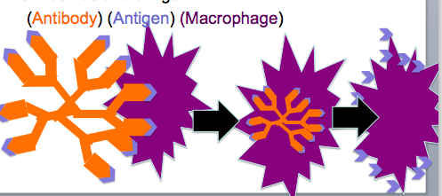

Immune System Notes: Specific

E. Cell-mediated Immunity
•T-Cells identify and attach to the antigens on the macrophage and the T cell divides
•Those new T Cells can become helper T-Cells and then Killer T-Cells
•Killer T-Cells find infected cells displaying antigen and pop them to stop infection
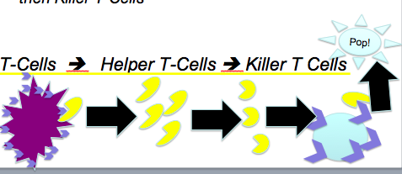
Immune System Notes: Acquired
F. Active Immunity
•Immunity after first exposure
•We can prepare our bodies so we have an active immunity if our bodies see the pathogen again.
•Vaccine: Injecting a weakened form of the pathogen to “train” your immune system.

Immune System Notes: Acquired
G. Passive Immunity
•Putting antibodies into our bodies
•Natural: From your mom
•Unnatural: Injected (ex: rabies vaccine)

Summary

