***Photosynthesis Notes***

Draw a Chloroplast

Comments/Questions

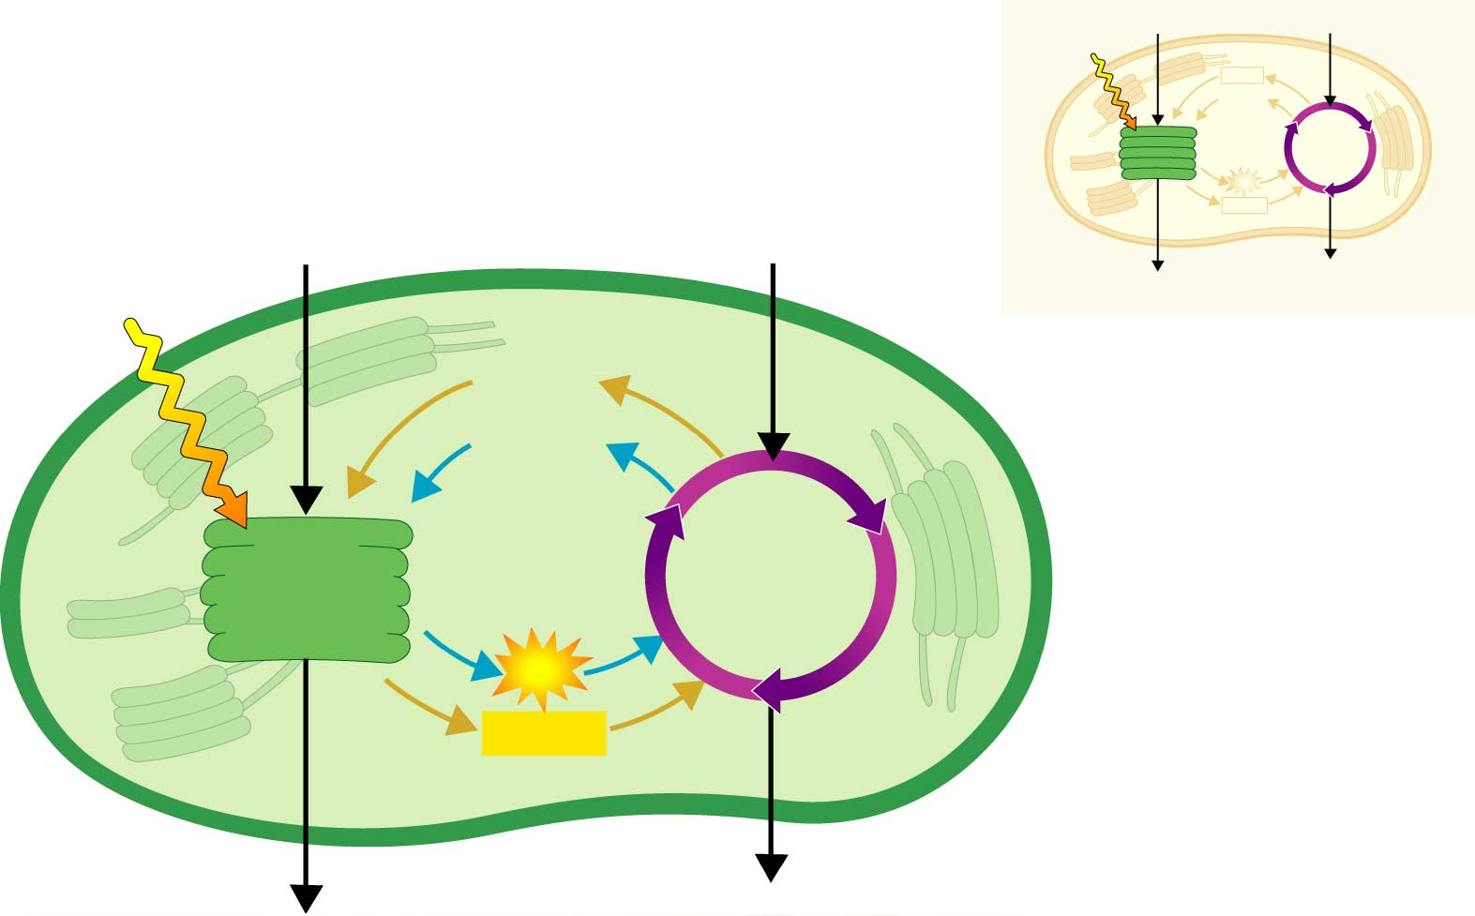

**TOC #**

***Photosynthesis:*** *Converting Light Energy into Chemical Energy*

I. Photosynthesis

A. Location -

I. The reactions of photosynthesis occur in the _____________________.

II. Chloroplasts:

1.What: Organelle in Plant _____________

2. Function: to Capture light energy

3. Where are they from? Endosymbiont theory of __________________

Evidence:

1. 2 cell membranes

2.Own DNA

B. Products & Reactants of Photosynthesis -

**Draw Reaction:**

**Show the Process** 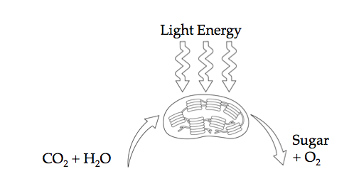

**C. Overview of Photosynthesis -**

I. In chloroplasts of photosynthetic organisms, the sun’s light energy is transformed into _________________ energy of carbohydrates (glucose).

Summary