***Photosynthesis Notes***

***D. Light Reaction***

I. Light is Absorbed and H20 is ________________

• Light energy is absorbed by pigments clustered in *photosystems*

* H2O is split producing H+, e- and ___________

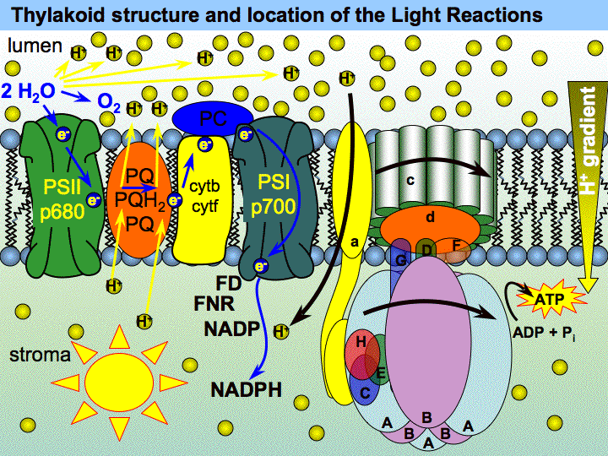

II. Electron Transport

•_______________ are transported along the electron transport chain

III. NADPH is formed - energy is stored

•_________________ and electrons combine with NADP+ to form NADPH

IV. Hydrogen ions (H+) accumulate

V. ___________ is formed - more energy is stored!

•Hydrogen ions (H+) activate an enzyme that bonds ADP and a _____________ group to form ATP

E. ATP

•ATP, adenosine triphosphate, is energy ____________ by cells.

•Energy is stored and released when phosphate bonds are formed and _____________________.

Comments/Questions

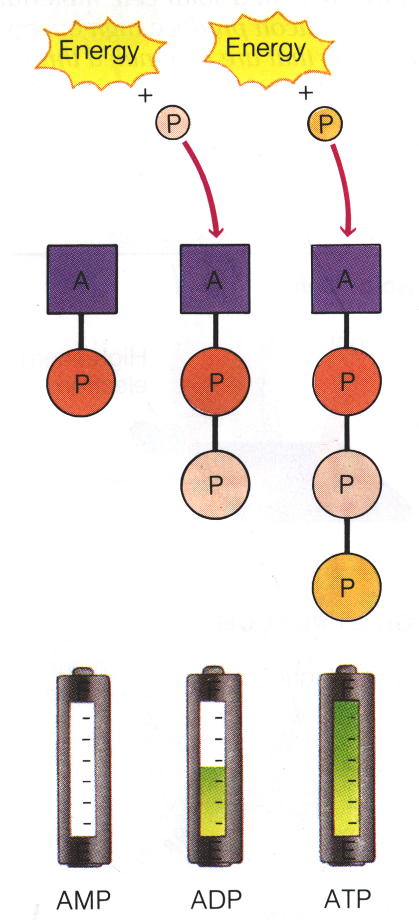

Summary