Study Guide
for Photosynthesis and Cellular Respiration
Resources for Studying:
PowerPoint on Photosynthesis and Cellular Respiration
Homework
Reading Activity on Photosynthesis
Prezi project
Textbook
Videos on my webpage
REVIEW YOUR rate of photosynthesis lab and Bromotymol Blue Demonstration notes

Energy:

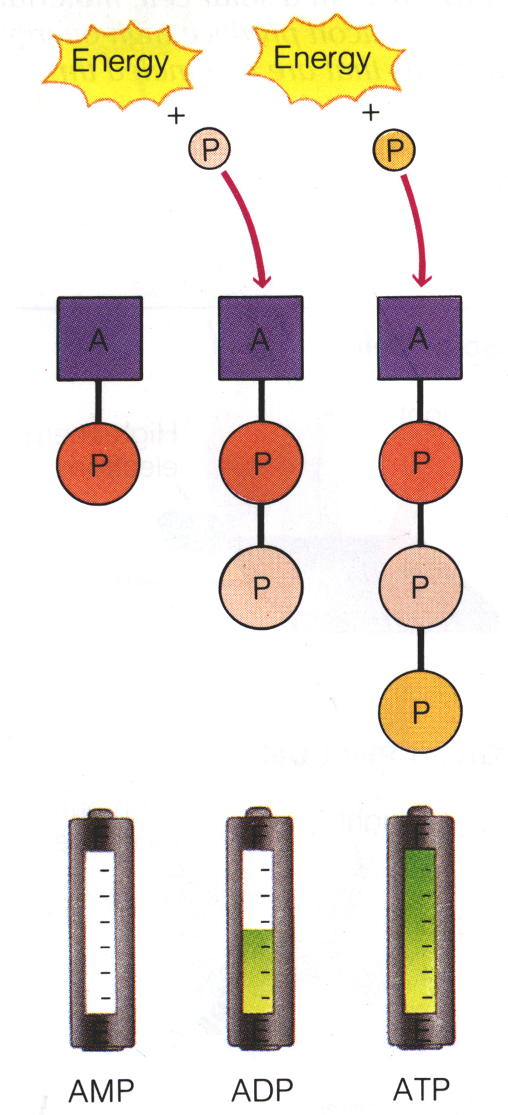 | - When you exercise why do you get hot and sweaty?  - What is ATP? And How do you make it into ADP? 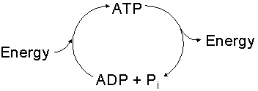  - 3. Where is energy stored in ATP?  - Which stores more energy and why?  ATP, AMP, ADP

Photosynthesis:
- Purpose:

- Location: (organismal level (plant or animal) and at a organelle level)

- Equation: Know products and reactants

- Understand each component of the photosynthesis prezi project:
–Equation of Photosynthesis and connection to changing our atmosphere
–ATP and ADP conversion and how energy is produced
–Chloroplasts and Chlorophyll
–Light Reaction
–Dark Reaction | Why is the term “dark reaction” confusing?

- Light and Dark reactions
Process | Location | Reactants  (What Goes In) | End Products  (What Comes Out)
Light Dependent Reactions
Light Independent Reactions
- Label the process of photosynthesis in the space below. Include the following structures and processes in your diagram: chloroplast, chlorophyll, light reaction, dark reaction, reactants, products, light, ATP

Cellular Respiration
- Purpose:

- Location:

- BALENCED Equation of Aerobic: Know products and reactants

- Types: (know why each is used)
    - Aerobic:
      - Pro:
    - Con:
  - Anaerobic:
    - Pro:
    - Con:
- Glycolysis:
  - Briefly summarize the events (reactions) that occur during glycolysis.

  - What is formed during glycolysis?
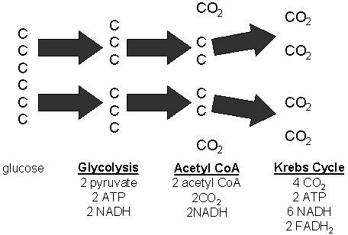

  - How much chemical energy (in the form of ATP molecules) is produced by the complete breakdown of 1 glucose molecule during glycolysis and aerobic respiration?

Connections: Cellular respiration to photosynthesis:
  - How are they connected?/Why are they called opposite processes?

  - Be able to draw and explain the figure below: (Type of question I may ask: Analyze the figure at below and discuss how cellular respiration and photosynthesis are related)
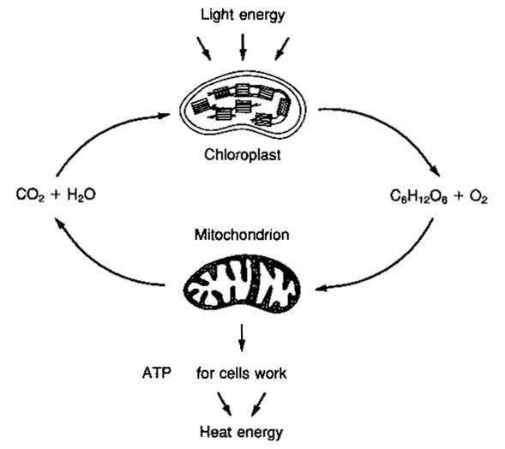
  - How are cellular respiration and breathing (respiration) related?

  - What is the function of the electron transport chain?
