ZooB
Lab Report Outline:
Title
Detailed
Describe the experiment
Example:
Hatchling Western Pond Turtle Righting Time as a Measure of Fitness and Survival.

Introduction

-3 References: Not Wiki

Materials and Methods
How you did what you did
Materials

Materials  - Paper Towels  - Stop Watch  - Thermometer  - Juvenile Turtles | Methods  - One turtle at a time (so that they don't see and learn from eachther.  - Flip a turtle over and time how long the turtle takes to flip ALL the way back over to right side up.  - Time 3 trails and take an average.

Results
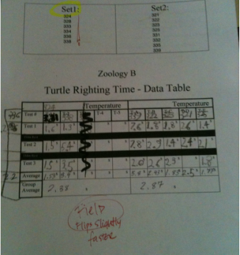
Turtles incubated in the field under fluctuating temperatures righted themselves on average in 2.38 seconds. Turtles incubated in the lab at Sonoma State University under constant temperature incubation righted successfully on average in 2.87 seconds.
- Use exact Numbers and reference your own data table
- Include your data table

Conclusion
Restate some of your premises from the intro:
- Why we were testing them: Fitness + if they will survive in the wild + compare the two types of incubation
- Type of turtle: species
Turtles incubated in the field under fluctuating temperatures were slightly faster at flipping over than turtles incubated in the lab at Sonoma State University under constant temperature incubation.
- Recommendation for ssu:
  - Release?
  - Next years incubation?
    - Possible: Release both – the difference between there righting time is very close so there levels of fitness are likely very similar.

References:
3 References: Not Wiki
Recommendation of how to site: http://zanniedallara.weebly.com/bibliographycitation.html

