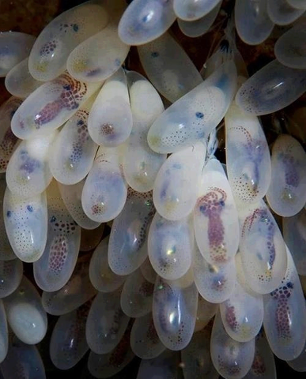
Octopus eggs!

Octopus reproduction is fairly uniform across species. When a female is ready to mate, she releases a chemical into the water that attracts males. They follow this chemical to the female, where they will often fight one another for the right to mate with the female. Sometimes the female will mate with more than one male. The same chemical that attracts the males stops the males from eating the female - cannibalism is common amongst octopodes.

Once it has been decided who will be mating, the male transfers packages of sperm called "spermatophores" to the female using his third right arm (which typically has no suckers). The female stores these, and then builds a den. She then seals the entrance. Once this is complete, she lays the eggs and fertilizes them as she goes using the spermatophore. A female octopus can lay tens of thousands of eggs, and they all hang from the roof of her den. Once laying is complete, she settles down and spends the next few months (up to six and a half, depending on the species) caring for the eggs. She ensures that bacteria and algae do not grow on them, and she blows water across them to ensure a constant oxygen supply.

The eggs will then hatch, and the mother removes the rocks sealing the entrance. The offspring swim to the surface, and the mother crawls out of her den and dies.

Interestingly, octopodes are known to be incredibly intelligent

Write a response:

