LABORATORY REPORT RUBRIC

A. Title

Summarizes experiment

Lab Report: TURTLE RACES – The Effect of Temperature on Turtle Speed

INTRODUCTION:

B. Purpose

Relevant information

Purpose of conducting the experiment

What do you hope to learn

C. Hypothesis

Use if/then/because statement

Explanation of prediction-predict outcome

Should be based on the purpose of the lab (not a summary of the purpose)
- Homeostasis: maintaining internal conditions, happy zone. This applies to this lab. Body temp returns to normal in endotherms using negative feedback loops. In ectotherms they have to move themselves. Endotherms are… warm blooded
Ectotherms cold. If trapped in a temp they cannot maintain homeo. So it effects there speed via there metabolism.
CONNECT WARM VS COLD BLOODED TO THE WAY MAINTAINs HOMEOSTASIS.
- Talk about negative feedback loop parts.
- Ectothermic
- Endothermic
- Feedback loop
- Western Pond Turtle (Clemmys marmorata)

Explain – species of special concern list *almost endangered

Newly hatched juveniles.

D. Materials/Procedure (Experimental Design)

List of all materials

Independent variable (if applicable)

Dependent variable (if applicable)

Controls/constants (if applicable)

List of procedure

Results and conclusion:

E. Data/Results

Qualitative data: Observations/Drawings/Notes:

Didn’t like containers

Quantitative data: Calculations, numbers, values

Data table with clear data

Data table is labeled and units are noted

Graphs present to show quantitative data

Both axis labeled properly

Key for data table

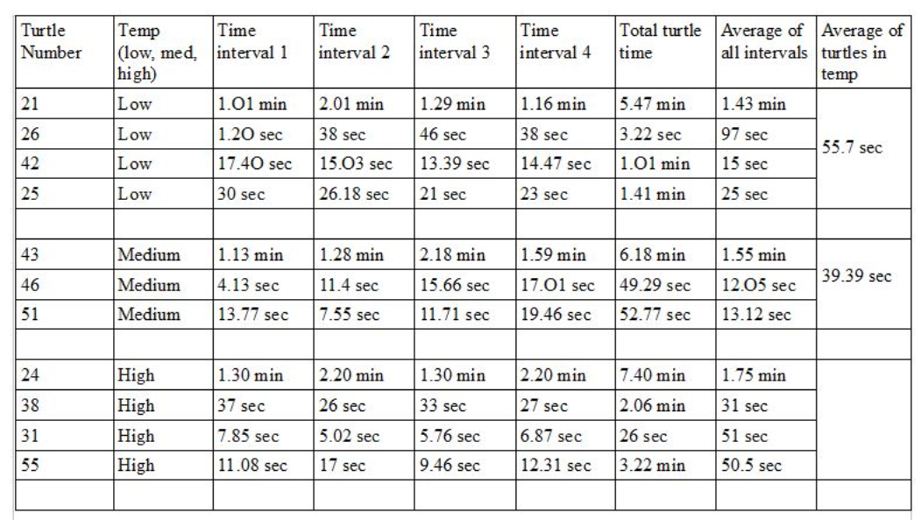

Units marked clearly

Proper type of graph used

Cold: 55.7 sec to cover 28.5cm

Room temp: 39.39 sec

Hot: 44.2 Sec

Fastest group was the room temp turtles. Was this expected? No, We hypothesized that the fastest turtles would be the hottest and our data does not reflect that. a possible reason is that the “hot” group was heated above their happy temperature – Above their maximum thermal threshold. (please explain why this is in your report)

Throw out turtle 24 from hot data set for “Failure to move”

F. Discussion/Questions

Analyze controls and variables

Compare findings to research

Make suggestions for improvement

Analysis questions (if present)

G. Conclusion

Restate your purpose

Explain major findings

Does data support your conclusion

Explanation of observed phenomena

Explain why data does/does not confirm your hypothesis.

