|  |
| --- |
| Screen shot 2012-05-01 at 4.31.05 PM.png |

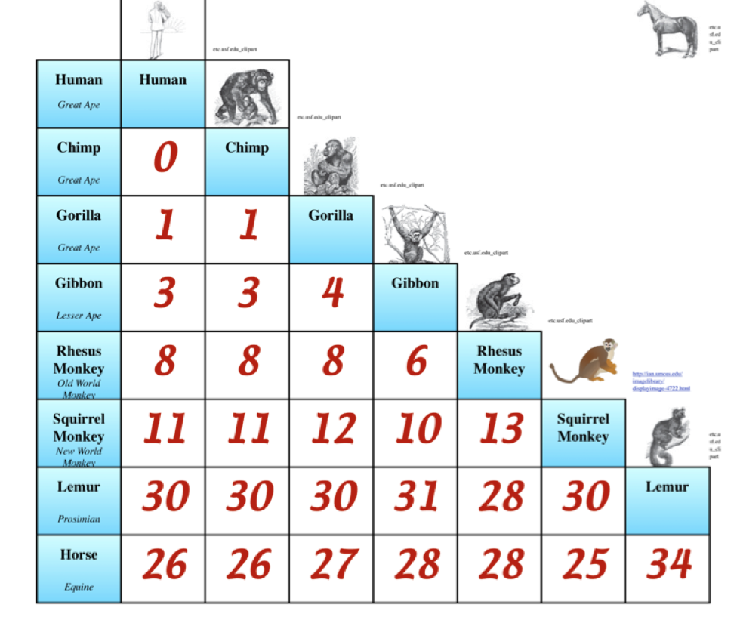

Screen shot 2012-05-01 at 5.06.18 PM.png

Screen shot 2012-05-01 at 5.06.37 PM.png

Screen shot 2012-05-01 at 5.06.47 PM.png

Screen shot 2012-05-01 at 5.06.18 PM.png

Screen shot 2012-05-01 at 5.06.37 PM.png

Screen shot 2012-05-01 at 5.06.47 PM.png

Screen shot 2012-05-01 at 5.06.55 PM.png

Screen shot 2012-05-01 at 4.44.27 PM.png

Screen shot 2012-05-01 at 4.46.46 PM.png

Screen shot 2012-05-01 at 4.47.22 PM.png

Screen shot 2012-05-01 at 4.48.03 PM.png

